|  |  |  |  |  |  |  |  |  |  |
| --- | --- | --- | --- | --- | --- | --- | --- | --- | --- |
| **NARAYANA ENGINEERING COLLEGE:GUDUR** | | | | | | | | | |
| IV Sem | | DESIGN THINKING FOR INNOVATION | | | | | | | R23 |
| Course Code | | Hours / Week | | | Total hrs | Credit | Max Marks | | |
| L | T | P | C | CIE | SEE | TOTAL |
| 23A99401 | | 1 | 0 | 2 | 48 | 2 | 30 | 70 | 100 |
| Course Objectives: The objective of this course is to familiarize students with design thinking process as a tool for breakthrough innovation. It aims to equip students with design thinking skills and ignite the minds to create innovative ideas, develop solutions for real-time problems. | | | | | | | | | |
| **Course Outcomes**: After successful completion of this course, the students should be able to: | | | | | | | | | |
| **CO 1** | Define the concepts related to design thinking.**(BL1, BL2)** | | | | | | | | |
| **CO 2** | Explain the fundamentals of Design Thinking and innovation **(BL1, BL2)** | | | | | | | | |
| **CO 3** | Apply the design thinking techniques for solving problems in various sectors. **(BL3)** | | | | | | | | |
| **CO 4** | Analyse to work in a multi disciplinary environment **(BL4)** | | | | | | | | |
| **CO 5** | Evaluate the value of creativity **(BL5)** | | | | | | | | |
| **CO 6** | Formulate specific problem statements of real time issues **(BL3, BL6)** | | | | | | | | |

|  |  |  |
| --- | --- | --- |
| **COURSE CONTENT** | | |
| **MODULE – 1** | **Introduction to Design Thinking** | **9H** |
| Introduction to elements and principles of Design, basics of design-dot, line, shape, form as fundamental design components. Principles of design. Introduction to design thinking, history of Design Thinking, New materials in Industry. | | |
| **MODULE – 2** | **Design Thinking Process** | **10H** |
| Design thinking process (empathize, analyze, idea &prototype), implementing the process in driving inventions, design thinking in social innovations. Tools of design thinking - person, costumer, journey map, brainstorming, product development  **Activity:** Every student presents their idea in three minutes, Every student can present design process in the form of flow diagram or flow chart etc. Every student should explain about product development. | | |
| **MODULE – 3** | Innovation | **10H** |
| Art of innovation, Difference between innovation and creativity, role of creativity and innovation in organizations- Creativity to Innovation- Teams for innovation- Measuring the impact and value of creativity.  **Activity:** Debate on innovation and creativity, Flow and planning from idea to innovation, Debate on value-based innovation. | | |
| **MODULE – 4** | **Product Design** | **10H** |
| Problem formation, introduction to product design, Product strategies, Product value, Product planning, product specifications- Innovation towards product design- Case studies  **Activity:** Importance of modelling, how to set specifications, Explaining their own product design. | | |
| **MODULE – 5** | **Design Thinking in Business Processes** | **9H** |
| Design Thinking applied in Business &Strategic Innovation, Design Thinking principles that redefine business – Business challenges: Growth, Predictability, Change, Maintaining Relevance, Extreme competition, Standardization. Design thinking to meet corporate needs- DesignthinkingforStartups-DefiningandtestingBusinessModelsandBusinessCases- Developing & testing prototypes.  **Activity:** How to market our own product, About maintenance, Reliability and plan for startup. | | |
| **Total hours:** | | **48 hours** |

|  |
| --- |
| Textbooks:  1. TimBrown, Change by design, Harper Bollins(2009) 2. IdrisMootee, Design Thinking for Strategic Innovation, 2013, John Wiley&Sons. |
| ReferenceBooks:  1. DavidLee, Design Thinking in the Classroom, Ulyssespress 2. ShrutinNShetty, Design the Future, NortonPress 3. WilliamLidwell, Universal Principles of Design-Kritinaholden,JillButter. 4. Chesbrough.H,TheEraofOpenInnovation– 2013   **Online Learning Resources:** https://nptel.ac.in/courses/110/106/110106124/ https://nptel.ac.in/courses/109/104/109104109/ https://swayam.gov.in/nd1_noc19_mg60/preview |

|  |  |
| --- | --- |
| **MODULE – 1** | **Introduction to Design Thinking** |

**Introduction to elements and principles of Design, basics of design-dot, line, shape, form as fundamental design components. Principles of design. Introduction to design thinking, history of Design Thinking, New materials in Industry.**

**INTRODUCTION TO ELEMENTS AND PRINCIPLES OF DESIGN:**

The elements and principles of design are fundamental concepts that guide the creation and evaluation of visual, functional, and interactive designs. These concepts are integral to design thinking, a human-centered approach to problem-solving that emphasizes empathy, ideation, prototyping, and testing. Understanding these elements and principles helps designers craft solutions that are both aesthetically pleasing and effectively address user needs.

**Elements of Design:**

The elements of design are the basic components used to build a design. They act as the raw materials that, when combined effectively, form compelling visuals and functional experiences. These include:

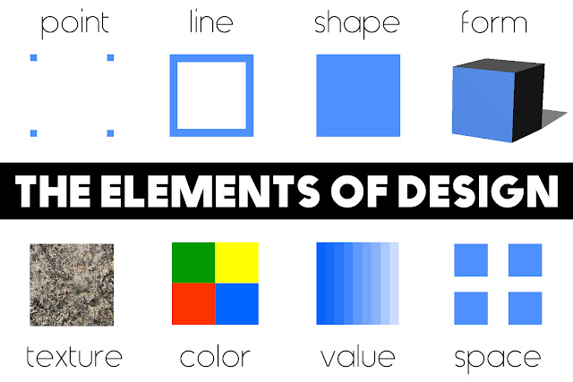

1. **Line**
   * Defines edges, creates divisions, and guides the eye.
   * Can be straight, curved, diagonal, or free-form.
   * Example: Used in wireframes to create structure.
2. **Shape**
   * 2D areas enclosed by lines or curves (e.g., circles, squares, triangles).
   * Shapes contribute to the overall structure and hierarchy.
3. **Form**
   * 3D objects that add depth and volume.
   * Commonly used in industrial or 3D digital design.
4. **Color**
   * Evokes emotions, establishes mood, and draws attention.
   * Includes hue (color), value (lightness/darkness), and saturation (intensity).
5. **Texture**
   * The surface quality of a design—real or implied.
   * Example: Smooth gradients vs. rough patterns.
6. **Space**
   * The area around, within, or between elements.
   * Includes positive space (occupied) and negative space (empty).
7. **Value**
   * The lightness or darkness of a color or element.
   * Creates contrast, depth, and emphasis.
8. **Point**

A point is the simplest type of line and is used to create basic shapes like squares and rectangles.

**Principles of Design:**

The principles of design describe how to use the elements effectively. They provide guidelines for creating balance, harmony, and functionality in a design.

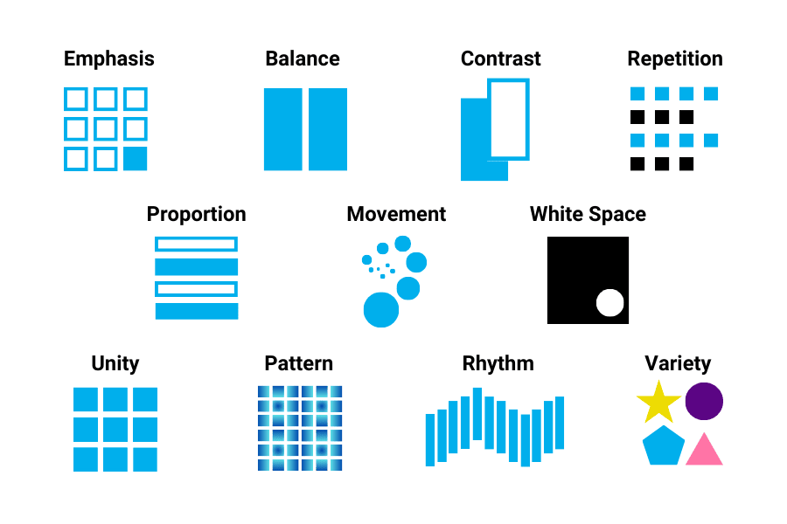

1. **Balance**
   * Distribution of visual weight across a design.
   * Types: Symmetrical, asymmetrical, radial.
2. **Contrast**
   * Differences between elements to create interest and focus.
   * Example: Light vs. dark, bold vs. thin.
3. **Emphasis**
   * Drawing attention to a focal point.
   * Achieved through size, color, position, or texture.
4. **Unity and Harmony**
   * Ensuring all parts of a design feel cohesive and connected.
   * Example: Consistent color palettes and typography.
5. **Proportion and Scale**
   * Relationship between sizes of elements.
   * Example: Larger elements for importance, smaller for details.
6. **Rhythm**
   * Creating patterns or movement through repetition.
   * Leads the viewer's eye through the design.
7. **Movement**
   * Directing the viewer's eye along a specific path.
   * Example: Arrows, leading lines, or placement of elements.
8. **Variety**
   * Introducing differences to maintain interest and avoid monotony.
   * Example: Combining different shapes, colors, or textures.
9. **Alignment**
   * Ensuring elements are arranged in a visually appealing way.
   * Example: Center, edge, or grid alignment.

**Basics of Design: Dot, Line, Shape, and Form as Fundamental Design Components:**

The dot, line, shape, and form are fundamental building blocks of design. These components are the foundation upon which all visual and spatial compositions are constructed. They serve as the primary tools for creating both simple and complex designs.

**1. Dot (Point):**

A dot is the simplest and most basic unit of design. It represents a single position in space and can have significant meaning despite its size.

* **Characteristics**:
  + The starting point of all design.
  + Static or dynamic depending on placement and repetition.
* **Visual Effects**:
  + Can create focus or emphasis.
  + Multiple dots can form patterns, textures, or suggest direction.
* **Examples in Design**:
  + Pixel in digital design.
  + Halftone patterns in printing.

**2. Line:**

A line is the connection between two points. It guides the viewer's eye and can convey direction, movement, or emotion.

* **Characteristics**:
  + Can vary in thickness, length, direction, and texture.
  + Types: Straight, curved, zigzag, dotted, or implied.
* **Visual Effects**:
  + Creates structure and organization.
  + Defines edges and shapes.
  + Suggests movement or flow.
* **Emotional Impact**:
  + Vertical lines convey stability or strength.
  + Horizontal lines suggest calmness.
  + Diagonal lines imply dynamism or tension.
* **Examples in Design**:
  + Frameworks in architecture or layouts.
  + Leading lines in photography or graphic design.

**3. Shape:**

A shape is a two-dimensional area enclosed by lines or curves. Shapes are fundamental for creating structure and visual impact.

* **Types of Shapes**:
  + **Geometric**: Circles, squares, triangles, rectangles. These shapes are precise and often convey order.
  + **Organic**: Freeform, irregular shapes inspired by nature. They feel fluid and dynamic.
  + **Abstract**: Simplified or stylized shapes used symbolically.
* **Functions in Design**:
  + Define space and create visual hierarchy.
  + Serve as building blocks for more complex compositions.
* **Examples in Design**:
  + Icons and logos.
  + Layout divisions or framing elements.

**4. Form:**

A form is a three-dimensional representation of a shape. It adds depth and volume to designs, making them feel more lifelike.

* **Characteristics**:
  + Forms have width, height, and depth.
  + Created through perspective, shading, and lighting.
* **Types of Forms**:
  + **Geometric Forms**: Cubes, spheres, cylinders—precise and structured.
  + **Organic Forms**: Irregular, flowing, and natural.
* **Visual Effects**:
  + Adds realism and physicality to a design.
  + Creates visual interest by simulating space and dimension.
* **Examples in Design**:
  + 3D modeling in product design or animation.
  + Sculptures and architectural structures.

**Introduction to Design Thinking:**

**Design Thinking** is a problem-solving approach that focuses on understanding and addressing human needs. It is widely used across industries to innovate solutions, improve processes, and create user-centered designs. Combining creativity, empathy, and practicality, Design Thinking provides a structured yet flexible methodology for tackling complex problems

**Key Principles of Design Thinking:**

1. **Human-Centered**
   * Places the user at the core of the process, ensuring solutions address real needs and improve experiences.
   * Emphasizes empathy to understand the perspectives of the people involved.
2. **Iterative Process**
   * Design Thinking is non-linear and involves cycles of testing, refining, and improving ideas based on feedback.
3. **Collaborative**
   * Encourages cross-disciplinary teamwork to leverage diverse perspectives and expertise.
4. **Experimental**
   * Promotes creativity by embracing experimentation, prototyping, and learning from failures.

**Stages of Design Thinking:**

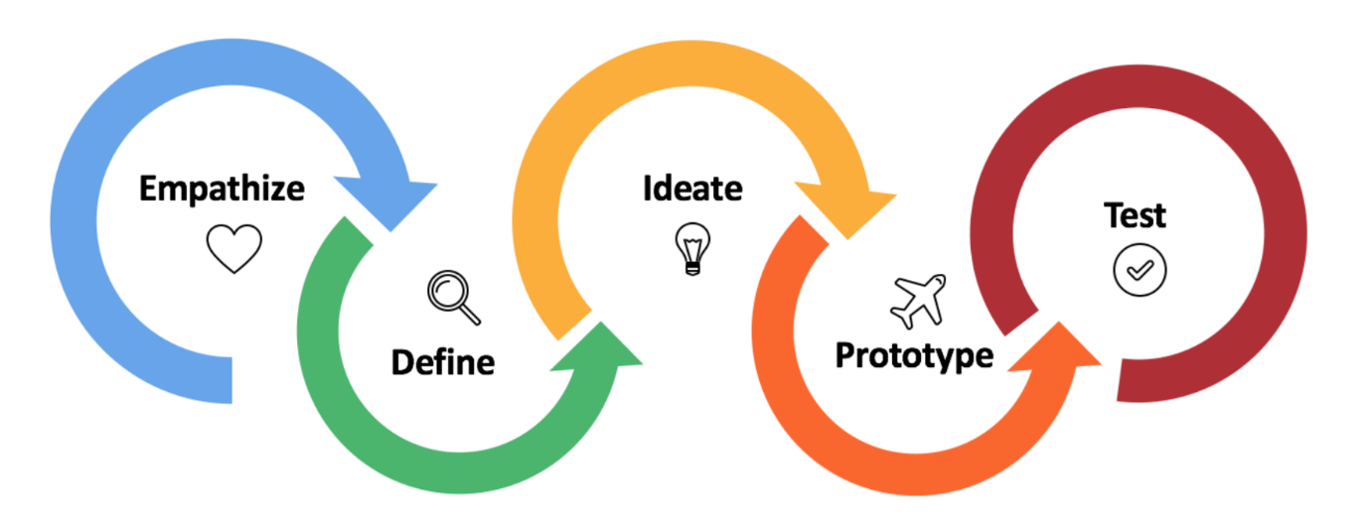

The process typically consists of five key stages:

1. **Empathize**
   * Understand the user’s needs, challenges, and desires through observation, interviews, and research.
   * Example: Conducting user interviews to identify pain points in a product or service.
2. **Define**
   * Synthesize findings into a clear problem statement or "point of view" that reflects the user's needs.
   * Example: Framing the problem as "How might we improve..." to focus on specific outcomes.
3. **Ideate**
   * Brainstorm and generate a wide range of creative ideas and potential solutions.
   * Example: Holding a workshop with team members to explore diverse concepts without judgment.
4. **Prototype**
   * Create tangible representations of ideas, such as sketches, models, or digital mockups.
   * Example: Developing a clickable wireframe to simulate an app's user interface.
5. **Test**
   * Gather user feedback on prototypes to refine and improve the solution.
   * Example: Conducting usability testing to observe how users interact with a product.

**Benefits of Design Thinking:**

* **Encourages Innovation**: Sparks fresh ideas and novel approaches to problem-solving.
* **Enhances User Experience**: Ensures solutions are tailored to real needs, improving satisfaction and usability.
* **Reduces Risk**: Prototyping and testing minimize the risk of launching ineffective solutions.
* **Fosters Collaboration**: Breaks silos and integrates diverse viewpoints for comprehensive solutions.

**Applications of Design Thinking:**

Design Thinking is versatile and applied in various fields, including:

* **Product Design**: Developing intuitive and functional products.
* **Healthcare**: Improving patient experiences and care delivery systems.
* **Education**: Creating innovative teaching methods and tools.
* **Business Strategy**: Solving organizational challenges and identifying growth opportunities.

**History of Design Thinking:**

The concept of **Design Thinking** has evolved over decades, drawing from various disciplines such as engineering, architecture, psychology, and business. It is not a sudden invention but a gradual development of ideas and practices aimed at solving problems creatively and collaboratively. Below is a chronological overview of the history of Design Thinking:

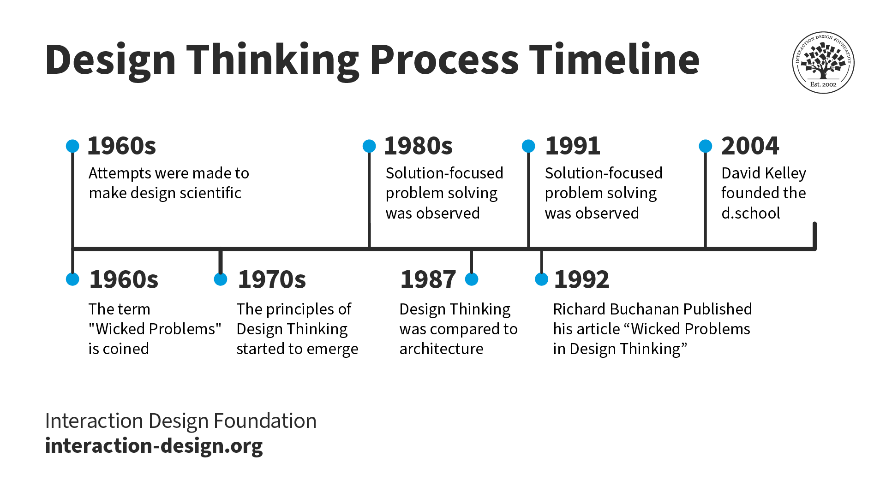

**1. Early Foundations (1900s–1960s)**

**Creative Problem-Solving Roots**

* Design Thinking traces its origins to **creative problem-solving** methods developed in fields like architecture and engineering.
* Pioneers like **Frederick Winslow Taylor** and **Frank Lloyd Wright** emphasized structured thinking and user-centric approaches in design and production.

**Gestalt Psychology (1920s–1940s)**

* Gestalt principles, focusing on perception and human experience, influenced early thoughts on user-centered design.

**Modern Design Principles**

* The **Bauhaus Movement** (1919–1933) introduced the integration of art, craft, and technology, emphasizing functionality and simplicity.
* The idea of designing with both aesthetics and functionality laid the groundwork for user-focused problem-solving.

**2. Emergence of Design Methodology (1960s–1980s)**

**The Design Methods Movement (1960s)**

* Scholars like **Herbert Simon** and **Horst Rittel** formalized the idea of design as a problem-solving process.
* **Herbert Simon**'s book *The Sciences of the Artificial* (1969) introduced the concept of a "systematic design process," describing design as a way of thinking about complex problems.
* **Horst Rittel** introduced the term **"wicked problems"** to describe problems that are complex, ambiguous, and have no clear solutions—ideal challenges for Design Thinking.

**IDEO and Early Human-Centered Design**

* Companies like **IDEO** (founded in 1991 but with roots in the 1970s) began to emphasize user-centered approaches and rapid prototyping to solve problems.

**Soft Systems Methodology (1970s)**

* Researchers like **Peter Checkland** emphasized a holistic approach to problem-solving that influenced systems thinking in design.

**3. The Rise of Design Thinking as a Discipline (1990s–2000s)**

**The Role of IDEO**

* **IDEO**, a design consultancy, played a critical role in popularizing Design Thinking as a distinct process.
* **David Kelley**, IDEO’s founder, emphasized empathy and user-centric innovation, combining technical feasibility, business viability, and user desirability.

**Stanford's d.school (2005)**

* The **Hasso Plattner Institute of Design at Stanford University** (commonly known as the d.school) formalized Design Thinking as a teaching framework.
* Its programs focused on training students and professionals in applying Design Thinking across disciplines.

**Tim Brown's Influence**

* **Tim Brown**, CEO of IDEO, published influential works, including *Change by Design* (2009), which explained the principles of Design Thinking to a broader audience.
* He positioned Design Thinking as a tool for innovation in business, education, and social sectors.

**4. Global Adoption and Expansion (2010s–Present)**

**Design Thinking in Business**

* Companies like **Apple**, **Google**, and **Airbnb** integrated Design Thinking to innovate and create user-centric products and services.
* Frameworks like the **Double Diamond Model** (developed by the UK’s Design Council) provided structured approaches for applying Design Thinking in organizations.

**Social Impact and Education**

* Design Thinking began to address social challenges, such as healthcare, education, and environmental issues.
* Schools, universities, and NGOs adopted Design Thinking to foster creativity, collaboration, and problem-solving in various sectors.

**Digital Transformation and UX Design**

* As technology advanced, Design Thinking became integral to **UX/UI design**, focusing on enhancing user experience in digital interfaces.

**New Materials in Industry:**

New materials in industry are increasingly influencing Design Thinking by offering innovative ways to address complex challenges, enhance user experience, and achieve sustainability. These materials provide designers with unique opportunities to rethink traditional solutions and develop products, structures, and systems that are more efficient, eco-friendly, and functional.

**1. Artificial Intelligence (AI) and Machine Learning Models**

* **Applications**: AI and machine learning models are increasingly becoming core elements of software applications, allowing for smarter, adaptive systems. These technologies are used in recommendation systems, natural language processing, autonomous vehicles, and more.
* **Design Thinking Relevance**: In the **Empathy** and **Ideation** phases, AI helps design teams understand user behavior more deeply by analyzing large datasets, allowing them to predict needs and tailor user experiences. During **Prototyping** and **Testing**, machine learning models are used to improve product recommendations, detect patterns, and optimize system behavior based on real-time data.

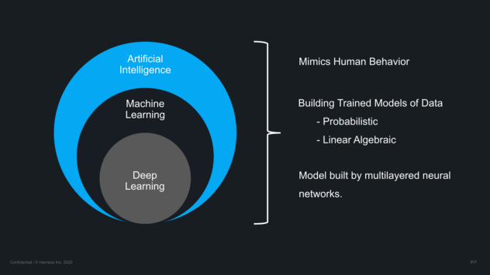

**2. Cloud Computing and Serverless Architectures**

* **Applications**: Cloud platforms (like **AWS**, **Google Cloud**, and **Azure**) and serverless computing allow developers to build scalable applications without worrying about the infrastructure. This provides flexible resources for hosting applications, storing data, and performing computations.
* **Design Thinking Relevance**: In **Product Development** and **Prototyping**, these tools give software designers the flexibility to quickly iterate, deploy, and scale solutions without significant upfront costs. This flexibility fosters **rapid prototyping** and **feedback loops**, helping designers develop solutions that better meet user needs.

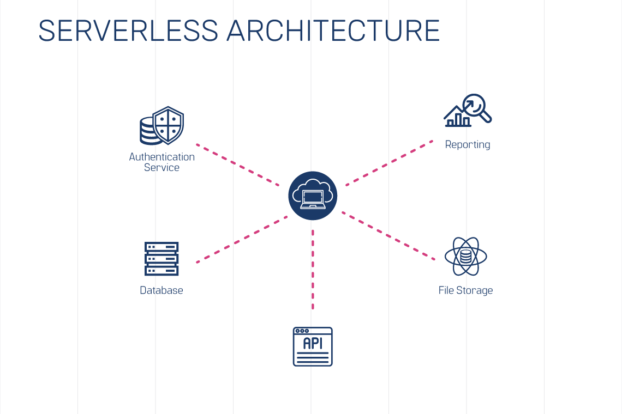

**3. Blockchain Technology**

* **Applications**: Blockchain offers a decentralized way of handling transactions and data storage, ensuring transparency and security. It's being used for applications beyond cryptocurrencies, such as **smart contracts**, **supply chain tracking**, and **identity verification**.
* **Design Thinking Relevance**: Blockchain can be integrated into the **Ideation** phase to envision secure, transparent systems. It also plays a crucial role in **testing** and ensuring product integrity, especially in industries like finance, healthcare, and logistics where trust and transparency are essential. During **Prototyping**, it allows developers to experiment with decentralized solutions that offer more secure ways of handling data.

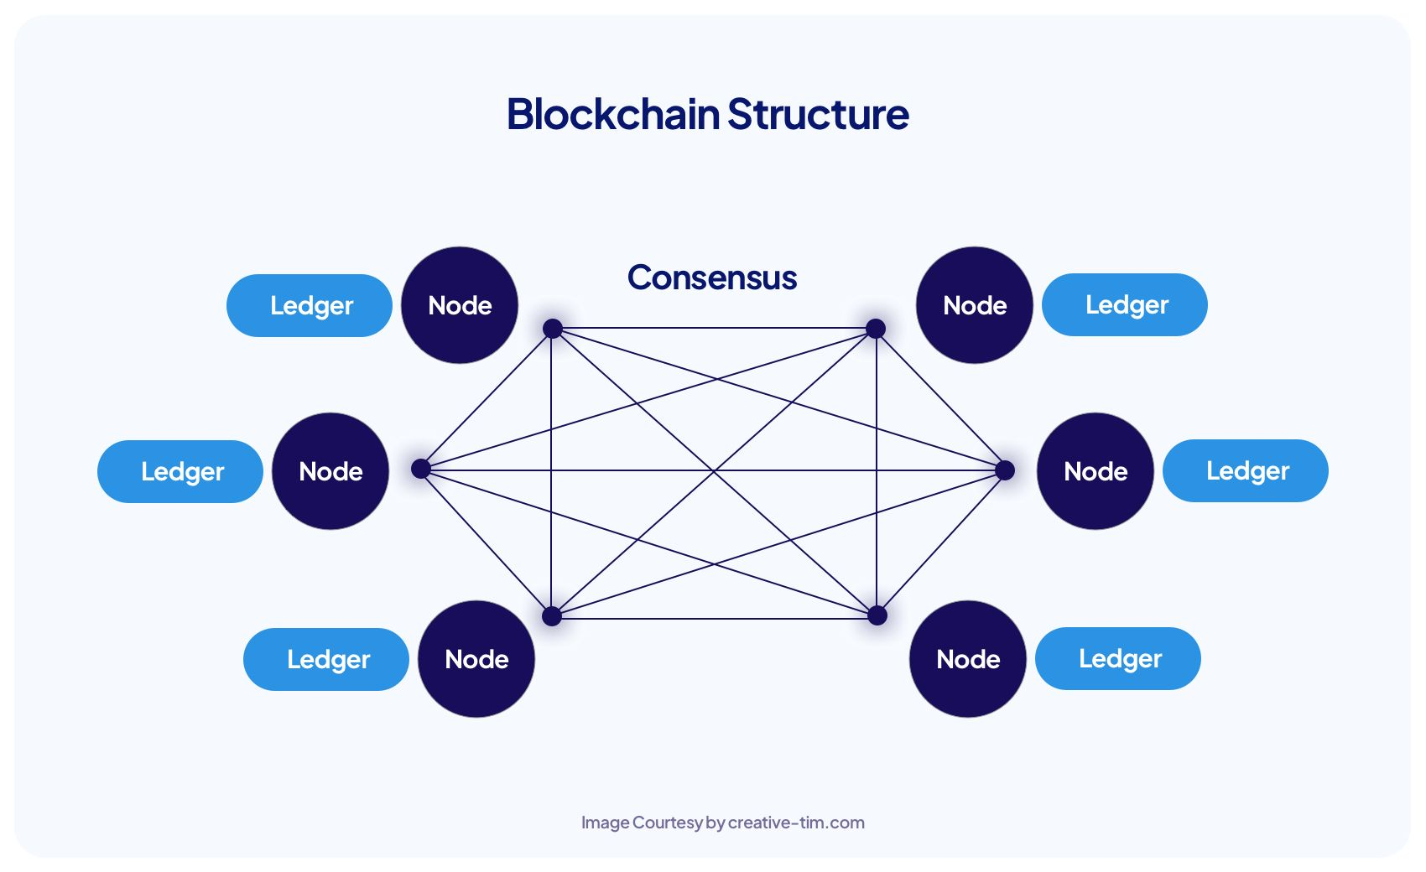

**4. Edge Computing**

* **Applications**: Edge computing pushes computation and data storage closer to the user (at the "edge" of the network), enabling faster responses, reduced latency, and better bandwidth management. This is important for real-time applications, such as **IoT devices**, **autonomous vehicles**, and **smart cities**.
* **Design Thinking Relevance**: In **Prototyping** and **Testing**, edge computing helps reduce latency issues in user-facing applications. It can enhance **user experience** by ensuring that products are responsive and function well in remote or low-connectivity areas, addressing the needs of users in various environments.

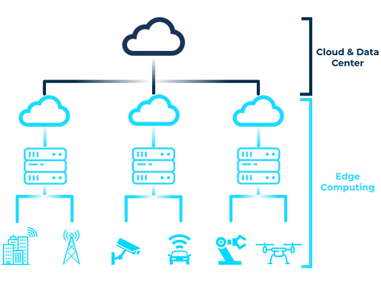

**5. Low-Code/No-Code Platforms**

* **Applications**: These platforms allow users to create applications with minimal or no coding experience, democratizing software development. Popular tools include **OutSystems**, **Bubble**, and **AppGyver**.
* **Design Thinking Relevance**: In the **Ideation** and **Prototyping** stages, low-code/no-code platforms allow non-developers (designers, business analysts, or even users) to quickly prototype software. This **empowers cross-functional teams** to participate in the design process, creating more **user-centered** solutions and accelerating the development cycle.

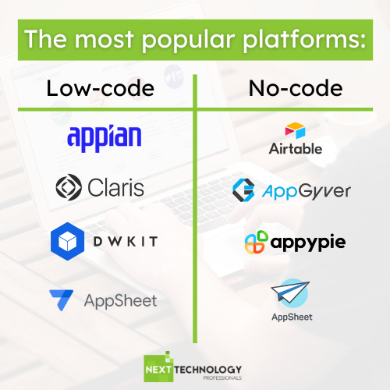

**6. Microservices Architecture**

* **Applications**: Microservices break down applications into smaller, independently deployable services, making software more scalable and maintainable. This is especially useful in modern web applications and cloud-based services.
* **Design Thinking Relevance**: Microservices allow for **rapid prototyping** and **iterative development**, where individual components can be designed, tested, and updated without disrupting the entire system. It also aligns with user feedback loops, allowing designers to adapt products to changing user needs more quickly and efficiently.

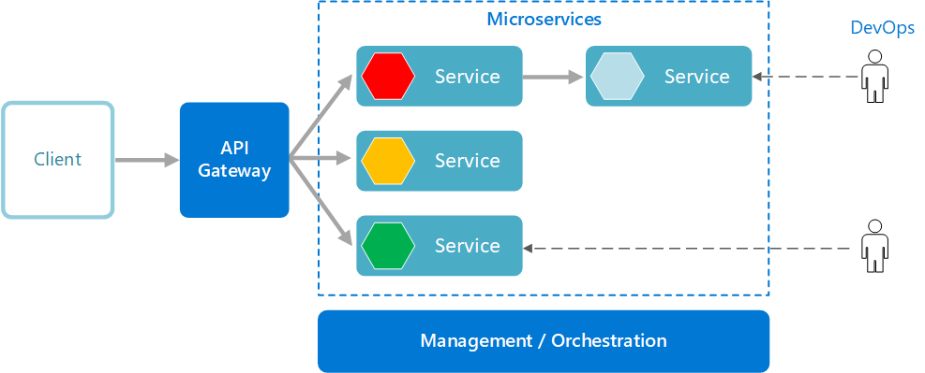

|  |  |
| --- | --- |
| **MODULE – 2** | **Design Thinking Process** |

**Design thinking process (empathize, analyze, idea &prototype), implementing the process in driving inventions, design thinking in social innovations. Tools of design thinking - person, costumer, journey map, brainstorming, product development.**

**DESIGN THINKING PROCESS:**

The Design Thinking process is a user-centered, iterative approach to problem-solving that encourages creativity, collaboration, and practical implementation. It is structured around five core stages, though the process is flexible and non-linear.

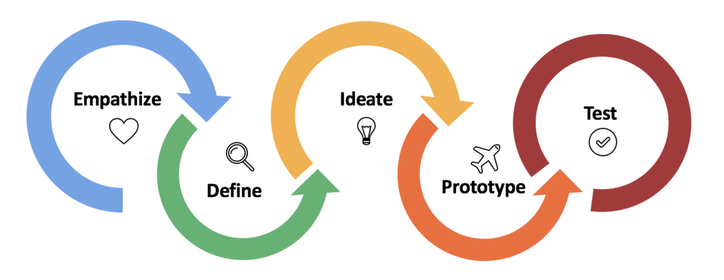

**1. Empathize**

* **Goal**: Understand the users and their needs by observing, engaging, and immersing yourself in their experiences.
* **Key Activities**: User interviews, observations, journey mapping, and empathy exercises.
* **Outcome**: A deep understanding of the problem from the user’s perspective.
* **Example**: Conducting interviews to understand challenges faced by commuters in public transportation.

**2. Define**

* **Goal**: Clearly articulate the problem you aim to solve based on insights gathered during the empathize phase.
* **Key Activities**: Synthesizing research, creating personas, and writing a problem statement or "How Might We" (HMW) questions.
* **Outcome**: A focused and actionable problem statement that guides the design process.
* **Example**: Framing the problem as: *"How might we make public transportation more accessible for elderly passengers?"*

**3. Ideate**

* **Goal**: Brainstorm a wide range of ideas and explore creative solutions.
* **Key Activities**: Brainstorming sessions, sketching, mind mapping, and collaborative workshops.
* **Outcome**: A pool of potential ideas to solve the problem, ready for prototyping.
* **Example**: Generating ideas such as a mobile app for seniors to plan trips, or ergonomic bus seats for easier access.

**4. Prototype**

* **Goal**: Create tangible representations of the ideas to explore their viability.
* **Key Activities**: Building low-fidelity models, sketches, or digital mockups that allow for quick testing and iteration.
* **Outcome**: Functional prototypes that can be tested and refined based on user feedback.
* **Example**: Developing a simple app prototype that displays public transit schedules with voice navigation.

**5. Test**

* **Goal**: Validate solutions by testing prototypes with users and gathering feedback.
* **Key Activities**: Usability testing, A/B testing, and observing user interactions with the prototype.
* **Outcome**: Insights into what works, what doesn’t, and areas for improvement, often leading to further iterations.
* **Example**: Testing the app prototype with elderly users to evaluate usability and accessibility.

**Implementing the Design Thinking process:**

Implementing the Design Thinking process to drive inventions involves applying its user-centered, iterative framework to generate innovative ideas and turn them into practical, impactful solutions. Here's how the process translates into driving invention and innovation:

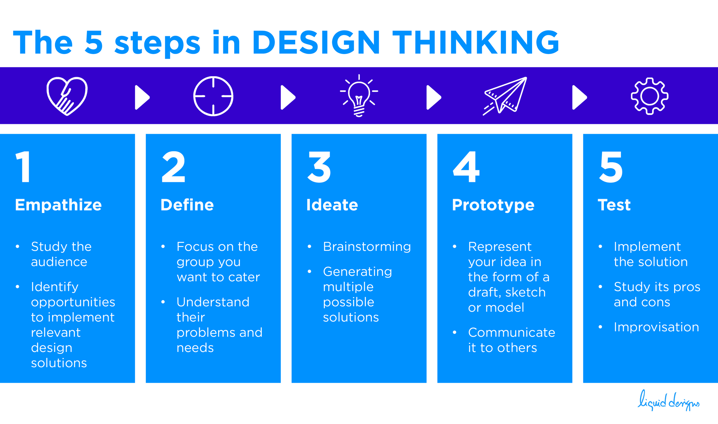

**1. Empathize: Identify User Needs**

* **Focus**: Deeply understand the challenges, desires, and pain points of the target audience.
* **Actions**:
  + Conduct ethnographic research, interviews, or surveys to gather insights about users.
  + Observe how users interact with current products or systems to uncover hidden needs.
* **Example**: To invent a more efficient home appliance, study user frustration with existing products, such as noise levels or energy consumption.

**2. Define: Frame the Problem**

* **Focus**: Narrow down the insights from the empathize phase to articulate a clear problem statement.
* **Actions**:
  + Use frameworks like the **"How Might We"** (HMW) questions to turn pain points into opportunities.
  + Synthesize user feedback into actionable insights.
* **Example**: *"How might we create a washing machine that conserves water while maintaining effective cleaning?"*

**3. Ideate: Generate Creative Solutions**

* **Focus**: Explore multiple approaches to solving the defined problem.
* **Actions**:
  + Organize brainstorming sessions with diverse teams.
  + Use methods like **SCAMPER** (Substitute, Combine, Adapt, Modify, Put to another use, Eliminate, Reverse) to enhance creativity.
  + Sketch or list as many ideas as possible without immediate judgment.
* **Example**: Propose concepts such as a washing machine with AI-driven sensors to optimize water use or one that reuses gray water for certain cycles.

**4. Prototype: Build Tangible Representations**

* **Focus**: Turn the most promising ideas into physical or digital models to test their feasibility.
* **Actions**:
  + Start with low-fidelity prototypes like sketches, mockups, or 3D-printed models.
  + Gradually refine into high-fidelity versions based on testing and feedback.
* **Example**: Develop a prototype washing machine with integrated sensors and modular components to demonstrate water efficiency.

**5. Test: Validate the Solution**

* **Focus**: Gather user feedback on the prototype and identify areas for improvement.
* **Actions**:
  + Conduct usability testing with real users.
  + Analyze performance metrics and align them with user expectations.
  + Iterate based on results, revisiting earlier stages if necessary.
* **Example**: Test the washing machine prototype with families in regions with water scarcity to measure both usability and impact.

**Keys to Driving Inventions with Design Thinking**

1. **User-Centric Innovation**: The process ensures inventions are tailored to real user needs, increasing adoption and impact.
2. **Iterative Refinement**: Regular testing and feedback allow for continuous improvement, reducing the risk of launching ineffective solutions.
3. **Collaboration**: Diverse perspectives in ideation and prototyping enhance creativity and problem-solving.
4. **Sustainability**: By integrating principles like circular design and eco-friendly materials, the process can lead to inventions with reduced environmental footprints.

**Design Thinking in Social Innovation:**

Design Thinking is a powerful methodology for addressing social challenges and driving social innovation. By focusing on human-centered solutions, it enables the development of impactful, scalable interventions that address pressing societal needs such as poverty, education, healthcare, and environmental sustainability.

**1. Empowering Marginalized Communities**

* **Example**: **Microfinance systems** like **Grameen Bank** have been designed to provide financial services to the unbanked population, especially in rural areas. Using Design Thinking, the focus was on understanding the barriers these communities face when accessing traditional banking systems, and creating simple, low-interest loans or savings programs that could foster entrepreneurship and economic independence.
* **Approach**: Designers immerse themselves in the communities, empathizing with people’s financial struggles and leveraging insights to create accessible, sustainable financial products.
* **Outcome**: Empowerment of individuals, especially women, to start businesses and improve their economic standing, while helping to reduce poverty and inequality.

**2. Healthcare Solutions**

* **Example**: **Portable diagnostic devices** like **the mHealth initiative** or **wearable health monitors** that track vital signs. These innovations, such as the use of low-cost blood testing equipment or sensors, are designed to make healthcare more accessible in remote areas or for people with limited access to hospitals.
* **Approach**: Through the empathize phase, designers work closely with patients and healthcare providers to identify pain points like affordability and accessibility. By creating affordable, simple-to-use devices, they can address health disparities in rural and underserved regions.
* **Outcome**: Improved health monitoring, earlier detection of diseases, and more accessible care, especially in low-income communities.

**3. Educational Access**

* **Example**: **One Laptop per Child (OLPC)** is a well-known initiative that used Design Thinking to develop affordable, durable laptops for children in developing countries. The goal was to improve access to education by providing students with tools that could facilitate learning in areas with limited resources.
* **Approach**: The ideation phase involved understanding the specific needs of students, teachers, and communities, and prototyping low-cost, energy-efficient devices tailored to the local environment. Feedback from users was incorporated to improve the design.
* **Outcome**: Enhanced educational opportunities, digital literacy, and new learning methods for students in underserved regions.

**4. Environmental Sustainability**

* **Example**: **Clean cookstoves** are an innovative solution to address the harmful emissions produced by traditional cooking methods in rural households. These stoves are more fuel-efficient and generate less smoke, improving both health outcomes and environmental sustainability.
* **Approach**: Designers used the empathy phase to understand the cooking habits and challenges of rural communities, incorporating local materials and cultural preferences into the design of the stove.
* **Outcome**: Reduced health risks related to indoor air pollution, decreased environmental impact from burning wood and other fuels, and increased energy efficiency.

**5. Water Access and Sanitation**

* **Example**: **The LifeStraw**, a portable water filter that turns contaminated water into safe drinking water, was designed using Design Thinking principles. It addresses the issue of safe drinking water in rural and disaster-stricken areas where traditional water filtration methods are not feasible.
* **Approach**: Through empathy, designers focused on the practical needs of people in areas with limited access to clean water, and created a user-friendly, affordable solution that could be deployed easily.
* **Outcome**: Improved health and access to clean water for millions of people in areas affected by water scarcity and contamination.

**6. Affordable Housing**

* **Example**: Social enterprises like **Habitat for Humanity** have employed Design Thinking to create affordable housing solutions for low-income families. The focus is on developing homes that are not only affordable but also sustainable and suited to the local environment.
* **Approach**: By involving future homeowners in the design process, designers can create homes that meet their specific needs while being cost-effective and environmentally sustainable.
* **Outcome**: Increased access to affordable housing and empowerment of families by allowing them to actively participate in the design and construction of their homes.

**7. Energy Solutions for Rural Areas**

* **Example**: The use of **solar lamps** or **small-scale solar-powered systems** in off-grid rural areas, where access to electricity is limited or non-existent. Innovations like **solar lamps** provide an affordable, sustainable energy source for light, improving education and safety after dark.
* **Approach**: Designers use the empathize phase to understand the daily routines and challenges of rural populations, especially those relying on kerosene lamps or candles, and develop solar-powered solutions that are affordable and effective.
* **Outcome**: Improved lighting, reduced carbon footprint, and better living conditions in off-grid areas.

**8. Food Security and Agricultural Innovation**

* **Example**: **Aquaponics systems** designed to help small-scale farmers grow food in regions where soil quality is poor or access to water is limited. These systems combine fish farming and plant cultivation, creating a sustainable way to produce food.
* **Approach**: In the empathize phase, designers learn about the challenges faced by farmers, such as soil erosion, water scarcity, and market access, to design solutions that provide food security with minimal environmental impact.
* **Outcome**: Increased food production and sustainable farming practices, improving food security for smallholder farmers and their communities.

**Tools of design thinking:**

**1. Personas**

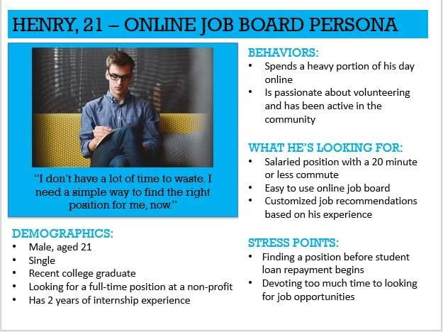

**Purpose**: Personas help create a shared understanding of users, focusing on their needs, behaviors, and pain points. This allows designers to create solutions that align closely with real-world users.  
**Tools**:

* **Persona Template**: A tool that defines key characteristics of the user (age, job, behaviors, goals, challenges) based on research.
* **Empathy Maps**: A visual tool used alongside personas to map out what the persona **thinks**, **feels**, **says**, and **does**.
* **User Research (Interviews, Surveys, Data Analytics)**: These are conducted to gather real data on users, which is then synthesized into personas.  
  **Benefits**: Ensures that design decisions are centered around real user needs, making solutions more user-friendly and effective.

**2. Customer Journey Map**

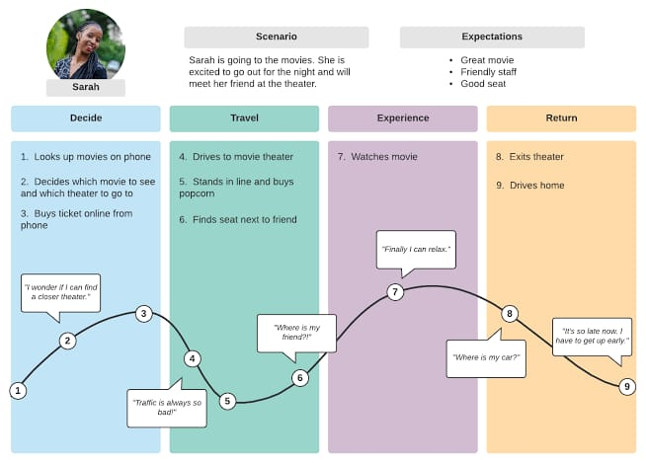

**Purpose**: A customer journey map visualizes the process a customer goes through when interacting with a product or service. It helps identify pain points, emotions, and key touchpoints throughout the user experience.  
**Tools**:

* **Journey Mapping Template**: A tool that allows teams to plot each phase of the user's experience, from initial awareness to post-purchase or service experience.
* **Touchpoint Analysis**: Identifying every point where the customer interacts with a service, such as online platforms, customer service calls, or physical stores.
* **Emotional Journey Mapping**: Visualizing how the user feels at each step of their journey, highlighting areas of frustration or delight.  
  **Benefits**: Helps prioritize areas for improvement, align teams on user needs, and enhance the overall experience by addressing customer pain points.

**3. Brainstorming**

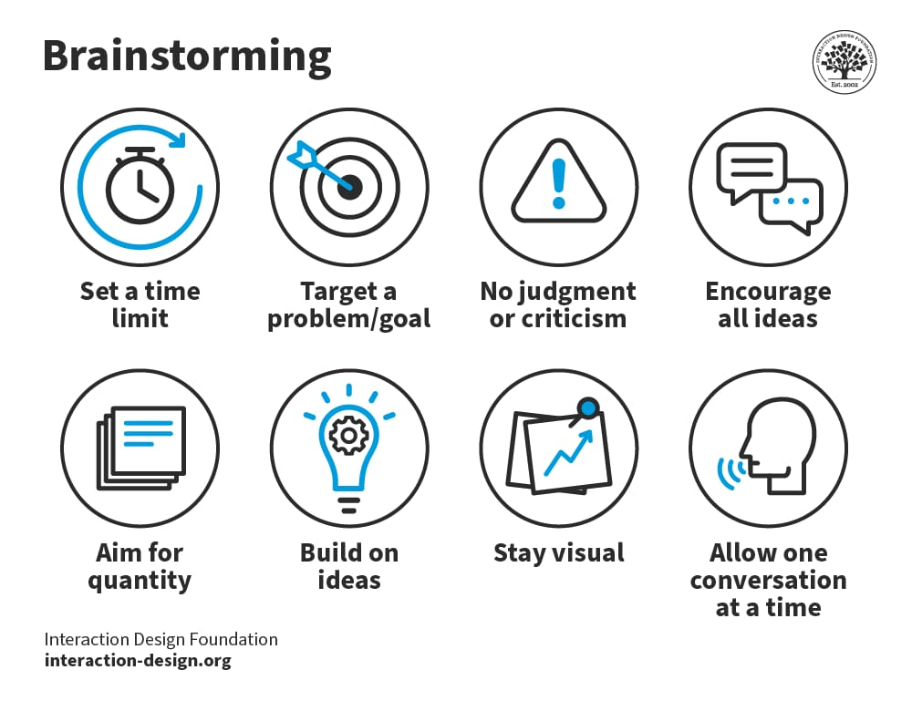

**Purpose**: Brainstorming is a creative process used to generate a wide variety of ideas without criticism. The aim is to encourage unconventional thinking and uncover innovative solutions.  
**Tools**:

* **Crazy 8s**: A quick ideation exercise where participants sketch 8 ideas in 8 minutes, forcing rapid ideation and broadening creative thinking.
* **Mind Mapping**: A visual tool to explore connections between ideas, facilitating a more structured way of brainstorming and developing complex concepts.
* **SCAMPER**: A technique for generating ideas by asking questions like: *What can be Substituted, Combined, Adapted, Modified, Put to another use, Eliminated, or Reversed?*  
  **Benefits**: Fosters creativity, diversifies solutions, and helps overcome conventional thinking. Teams are encouraged to explore a wide range of possibilities.

**4. Product Development Tools**

**Purpose**: Tools used in product development help bring ideas to life and iterate on them, ensuring that the final product addresses user needs effectively.  
**Tools**:

* **Wireframes**: Simple, visual representations of a product’s layout and structure, used to plan user interactions and screen flows (especially for digital products).
* **Prototypes**: Prototypes are early models of a product or service created to test functionality and user experience. These can range from low-fidelity (e.g., paper models) to high-fidelity (interactive digital prototypes).
* **MVP (Minimum Viable Product)**: A version of the product with just enough features to test key hypotheses and gather feedback from real users, typically before full-scale development.
* **Rapid Prototyping**: A process of quickly building prototypes (both digital and physical) to experiment and test ideas with users. Tools like **Figma**, **Sketch**, or **InVision** are commonly used for digital prototypes.
* **Role Playing**: Simulating user interactions with prototypes to gain deeper insights into potential challenges or opportunities in the user experience.  
  **Benefits**: Allows designers to validate assumptions, gather feedback quickly, and iterate on concepts before full-scale development, minimizing risk.

|  |  |
| --- | --- |
| **MODULE – 3** | Innovation |

**Art of innovation, Difference between innovation and creativity, role of creativity and innovation in organizations- Creativity to Innovation- Teams for innovation- Measuring the impact and value of creativity.**

**ART OF INNOVATION:**

The art of innovation in design thinking is about blending creativity, strategy, and empathy to produce solutions that are not only functional but also transformative. It elevates problem-solving into a creative and meaningful practice. Here's how the "art" of innovation is expressed in design thinking:

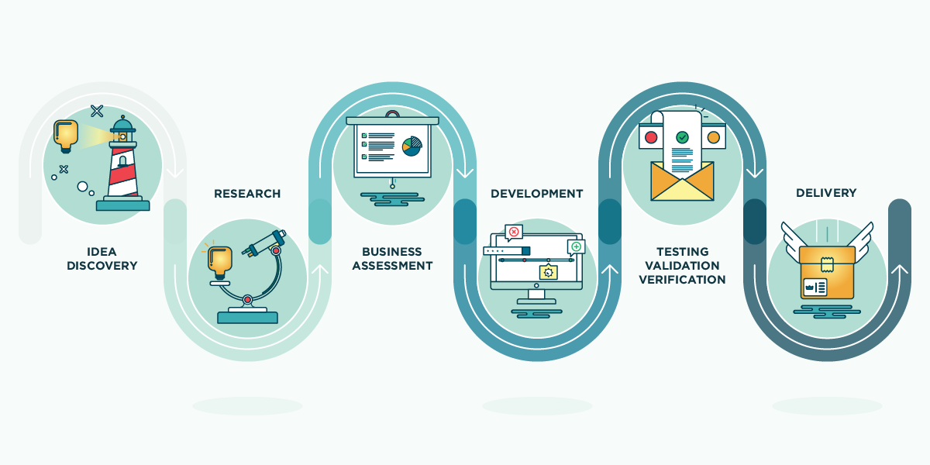

This is a visual representation of the innovation process or a product development lifecycle. Here's a breakdown of the stages depicted:

1. Idea Discovery
   * The initial stage focuses on identifying problems, brainstorming solutions, and uncovering new opportunities. This phase is all about generating and capturing innovative ideas.
2. Research
   * Conducting detailed investigations to understand the feasibility, context, and requirements of the idea. This includes market research, competitor analysis, and technical exploration.
3. Business Assessment
   * Evaluating the idea's business potential. This includes analyzing profitability, scalability, and alignment with organizational goals. A business plan or strategy might be developed during this phase.
4. Development
   * Turning the idea into a tangible product or service. This includes designing, coding, engineering, and creating prototypes or MVPs (Minimum Viable Products).
5. Testing, Validation, and Verification
   * Ensuring that the product or service meets quality standards and customer expectations. This phase often involves usability testing, quality assurance, and refinement based on feedback.
6. Delivery
   * Launching the product or service to the market. This stage includes deployment, marketing, and customer onboarding.

**Examples of the Art of Innovation**

**Technology Sector**

* **Apple iPhone**  
  The iPhone revolutionized communication by blending a phone, iPod, and internet browser into one device. Apple followed rigorous research, human-centered design, iterative prototyping, and sleek delivery to ensure its success.
* **Tesla Electric Vehicles**  
  Tesla disrupted the automotive industry by innovating electric vehicles with exceptional battery technology, software integration, and a strong focus on user experience.

**Healthcare**

* **CRISPR Gene Editing**  
  This groundbreaking technology emerged from extensive research and development, enabling precise genetic modifications with immense potential for curing diseases.
* **Telemedicine Platforms**  
  Companies like Teladoc used the innovation process to meet modern healthcare needs by integrating technology into virtual consultations and care.

**Consumer Goods**

* **Dyson Vacuums**  
  James Dyson applied principles of iterative design and engineering to create powerful, bagless vacuum cleaners, transforming a common household appliance.
* **Beyond Meat**  
  Through research and development, Beyond Meat innovated plant-based meat products, offering sustainable, nutritious, and tasty alternatives to traditional meat.

**Entertainment and Media**

* **Netflix Streaming Service**  
  Netflix transitioned from DVD rentals to a streaming platform, leveraging technology and business assessment to lead the entertainment industry.

**Education**

* **Duolingo**  
  The gamified language learning app combined user-centric design and technology to make education accessible, engaging, and scalable worldwide.

**DIFFERENCES BETWEEN INNOVATION AND CREATIVITY:**

**Creativity** and **innovation** are closely related but distinct concepts in **design thinking**. Both play critical roles in generating and implementing ideas, but they serve different purposes. Here's a comparison:

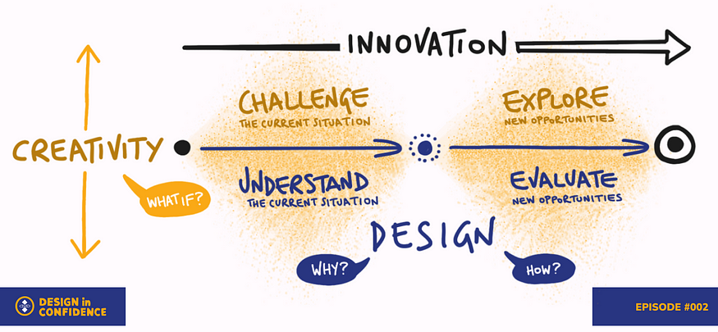

1. **Creativity**:
   * **Definition**: The ability to generate new and original ideas. It is often represented by asking "What if?" and thinking outside the box.
   * **Focus**: Divergent thinking and brainstorming to challenge norms or imagine possibilities.
   * **Purpose**: Inspires exploration of potential solutions by imagining scenarios beyond current constraints.
2. **Innovation**:
   * **Definition**: The process of implementing creative ideas to generate value, whether in the form of products, services, or processes.
   * **Focus**: Translating creative ideas into tangible outcomes. It involves both exploration of opportunities and evaluation of their feasibility.
   * **Purpose**: Moves ideas toward practical application, asking questions like "How?" and "Why?" to ensure relevance and impact.

**Key Differences:**

* Creativity is about generating ideas, while innovation is about applying those ideas effectively.
* Creativity is more abstract and exploratory, whereas innovation is practical and action-oriented.

**3. Example**

* **Creativity in Design Thinking**:  
  A team designing a bicycle for urban commuting imagines features like solar-powered lights, foldability, and integrated GPS.

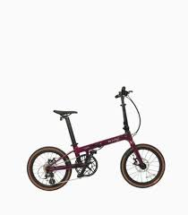

* **Innovation in Design Thinking**:  
  The team prototypes the foldable bike, tests it with users, and refines the design for production, making it affordable and eco-friendly.



**Key Relationship**

Creativity is the **starting point**, providing the raw material (ideas) for innovation. Innovation, in turn, is the **execution** that brings those ideas to life, ensuring they are practical, valuable, and impactful.

In essence:

* **Creativity** is about imagining the new.
* **Innovation** is about making the new real.

**ROLE OF CREATIVITY AND INNOVATION IN ORGANIZATIONS:**

**Creativity** and **innovation** are essential for the success and growth of organizations in today's fast-paced, competitive environment. While they are interrelated, each plays a unique role in driving organizational performance and fostering a culture of progress.

**1. Creativity in Organizations**

Creativity is the ability to generate original and valuable ideas. In organizations, it serves as the foundation for problem-solving, decision-making, and future planning.

**Role of Creativity:**

* **Problem-Solving**:  
  Encourages unconventional approaches to challenges, enabling organizations to overcome obstacles with fresh perspectives.
* **Idea Generation**:  
  Fuels brainstorming and ideation, ensuring a constant flow of potential improvements in products, services, and processes.
* **Adaptability and Agility**:  
  Allows organizations to respond effectively to changing market demands and unpredictable circumstances.
* **Employee Engagement**:  
  Empowers employees by valuing their unique input, fostering a sense of purpose and collaboration.

**Examples:**

* Google’s "20% Time" policy encourages employees to dedicate time to personal creative projects, leading to innovations like Gmail.
* Pixar’s open feedback culture stimulates creative storytelling and innovative filmmaking.

**2. Innovation in Organizations**

Innovation is the practical application of creative ideas to create value, whether through new products, services, or operational efficiencies. It translates ideas into tangible outcomes that enhance competitiveness and profitability.

**Role of Innovation:**

* **Driving Growth**:  
  Introduces new revenue streams, markets, and customer segments through groundbreaking products or services.
* **Maintaining Relevance**:  
  Keeps organizations ahead of competitors by meeting evolving customer needs and technological advancements.
* **Improving Efficiency**:  
  Streamlines operations and reduces costs through process innovations and automation.
* **Building a Competitive Advantage**:  
  Differentiates organizations in the marketplace, making them more appealing to customers and investors.

**Examples:**

* Tesla’s electric vehicle innovations disrupted the automotive industry, leading the shift toward sustainable transportation.
* Amazon’s advancements in logistics, such as drone delivery and predictive shipping, redefined e-commerce.

**CREATIVITY TO INNOVATION:**

The journey from **creativity to innovation** involves transforming imaginative ideas into practical, value-driven solutions. While creativity sparks the original concepts, innovation applies these concepts to create real-world impact. This progression is a structured yet dynamic process crucial for solving problems, improving operations, and driving organizational growth.

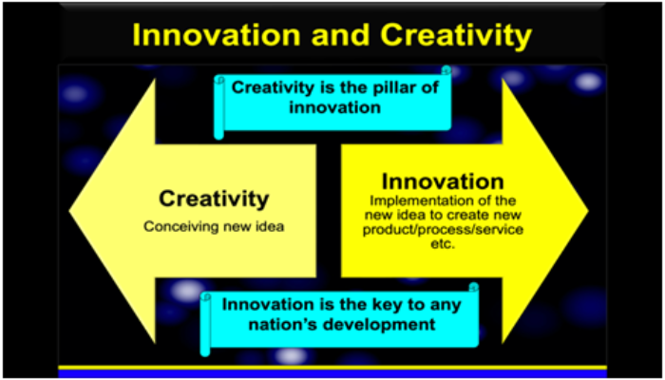

**Steps from Creativity to Innovation**

1. **Idea Generation (Creativity Stage)**
   * **What Happens**:  
     Creativity begins with brainstorming and exploring new possibilities without constraints. It involves divergent thinking, where multiple ideas are generated without immediate judgment.
   * **Key Activities**:
     + Brainstorming sessions.
     + Observing user behavior for insights.
     + Encouraging "blue-sky" thinking (thinking without limits).
   * **Example**:  
     A team conceptualizes a smartphone app that can scan food labels to provide allergy alerts.
2. **Idea Evaluation**
   * **What Happens**:  
     The raw ideas are critically assessed for feasibility, relevance, and potential impact. This involves convergent thinking, which narrows down options to the most promising ones.
   * **Key Activities**:
     + SWOT analysis (Strengths, Weaknesses, Opportunities, Threats).
     + User feedback and preliminary testing.
   * **Example**:  
     The team selects the food allergy alert app over other ideas based on its market need and technical feasibility.
3. **Prototyping and Experimentation (Bridge Between Creativity and Innovation)**
   * **What Happens**:  
     Selected ideas are turned into prototypes or models to test their viability. Rapid iteration ensures the solution aligns with user expectations and requirements.
   * **Key Activities**:
     + Building prototypes or mock-ups.
     + Conducting usability tests.
     + Iterating based on feedback.
   * **Example**:  
     Developers create a basic version of the allergy alert app and test it with a focus group.
4. **Implementation (Innovation Stage)**
   * **What Happens**:  
     The refined solution is developed and scaled for real-world use. It’s no longer just an idea but a tangible, functional product or service.
   * **Key Activities**:
     + Full-scale product development.
     + Marketing and launch strategies.
     + Monitoring user adoption and performance.
   * **Example**:  
     The allergy alert app is released on app stores, with marketing campaigns targeting health-conscious consumers.
5. **Impact Assessment and Continuous Improvement**
   * **What Happens**:  
     After implementation, the solution's success is measured, and improvements are made based on feedback. This keeps the innovation relevant and effective.
   * **Key Activities**:
     + Analyzing metrics (e.g., downloads, user engagement).
     + Updating features or addressing bugs.
   * **Example**:  
     The app adds new features like personalized diet plans based on user suggestions.

**Factors Enabling the Transition from Creativity to Innovation**

1. **Organizational Support**:
   * Resources, time, and encouragement for creative exploration.
   * Leadership that values and supports experimentation.
2. **Collaboration**:
   * Diverse teams that bring varied perspectives and skills.
   * Open communication channels to share and refine ideas.
3. **Risk-Taking Culture**:
   * A willingness to experiment and learn from failures.
4. **User-Centered Approach**:
   * Involving end-users throughout the process to ensure relevance and usability.
5. **Technology and Tools**:
   * Leveraging technology to prototype, test, and scale solutions efficiently.

**Real-World Example: Apple**

* **Creativity**: The concept of a device that combines music, phone, and internet browsing into one sleek product.
* **Innovation**: The iPhone, which revolutionized the smartphone industry by turning this idea into a market-ready product with intuitive design, usability, and ecosystem integration.

**Teams for innovation:**

**Innovation Teams for Measuring the Impacts and Values of Creativity**

Measuring the **impacts** and **values** of creativity within innovation teams involves assessing both the tangible outcomes of creative efforts (such as product success or market growth) and the intangible aspects (such as team culture, user experience, and brand perception). By effectively tracking and measuring these aspects, organizations can understand how creativity contributes to business success and innovation. Below is a detailed breakdown of the roles, methods, and metrics that innovation teams use to measure both the impact and value of creativity.

**1. Key Roles in Innovation Teams for Measuring Impacts and Values of Creativity**

**a. Innovation Manager / Lead**

* **Role**: Oversees the creative process, ensuring that innovative efforts align with strategic business goals.
* **Responsibilities**: Defines key performance indicators (KPIs) and sets success criteria for measuring creativity’s contribution to both the business and user outcomes.
* **Contribution**: Measures the overall impact of creativity by linking innovation activities to business performance and organizational objectives.

**b. Design Thinking Facilitator**

* **Role**: Guides the team through the design thinking process, ensuring that creativity is used effectively to solve user problems.
* **Responsibilities**: Leads workshops, ideation sessions, and prototyping. Ensures that creative ideas are tested and validated by users.
* **Contribution**: Measures the impact of creativity in user-centered design and the relevance of ideas to customer needs.

**c. User Experience (UX) Researcher**

* **Role**: Gathers and analyzes user feedback to measure how creativity influences user satisfaction and experience.
* **Responsibilities**: Conducts user testing, surveys, and usability studies to validate whether creative solutions address user pain points.
* **Contribution**: Measures the user experience impact, linking creativity to satisfaction and engagement.

**d. Product Manager**

* **Role**: Ensures that creative ideas align with product and business goals.
* **Responsibilities**: Tracks how creative solutions impact product development timelines, market fit, and business objectives such as revenue or customer acquisition.
* **Contribution**: Measures how creativity drives product success and its contribution to the business's bottom line.

**e. Data Analyst / Performance Metrics Specialist**

* **Role**: Provides data-driven insights into the performance of creative solutions.
* **Responsibilities**: Tracks metrics such as engagement rates, sales, and customer retention that result from creative innovations.
* **Contribution**: Quantifies the impact of creativity through performance data, tracking business metrics and user behavior.

**f. Organizational Culture and HR Lead**

* **Role**: Ensures that creativity is fostered within teams and aligns with the organization's culture.
* **Responsibilities**: Measures employee engagement and creativity culture within the organization.
* **Contribution**: Assesses the intangible value of creativity in terms of employee satisfaction, retention, and team collaboration.

**2. Key Metrics for Measuring the Impact and Value of Creativity**

Innovation teams measure both **impact** (how creativity affects business outcomes) and **value** (the broader, often intangible benefits that creativity brings to the organization). Below are metrics commonly used by innovation teams to measure creativity’s impact and value:

**a. Business Impact Metrics**

* **Revenue Growth and Profitability**:  
  Measures the direct financial impact of creative innovations, such as new products or services that lead to increased sales or reduced costs.  
  *Impact*: Demonstrates how creativity leads to tangible business outcomes.
  + *Example*: Increased revenue from a newly launched product inspired by creative design thinking.
* **Market Share and Competitive Position**:  
  Tracks whether creative solutions result in increased market share or a competitive advantage.  
  *Impact*: Reflects how creative ideas can differentiate the organization in the market.
  + *Example*: A creative marketing campaign that boosts brand visibility and market share.
* **Return on Investment (ROI)**:  
  Calculates the ROI of creative initiatives by comparing the financial outcomes against the investment made.  
  *Impact*: Quantifies the value derived from creative investments.
  + *Example*: ROI of a new digital product developed through creative ideation.

**b. User-Centered Impact Metrics**

* **User Satisfaction and Experience**:  
  Measures how creative innovations improve user experience and satisfaction, often through **Net Promoter Score (NPS)**, **Customer Satisfaction (CSAT)**, and feedback surveys.  
  *Impact*: Shows how creativity enhances user engagement and loyalty.
  + *Example*: Positive feedback from users regarding an innovative new feature in an app.
* **Customer Retention and Loyalty**:  
  Tracks how creative solutions help retain customers and foster brand loyalty.  
  *Impact*: Indicates that creative ideas resonate with customers, fostering long-term relationships.
  + *Example*: A creative product update that reduces churn by adding valuable features that users love.
* **Adoption Rates**:  
  Measures the speed and scale at which users adopt creative innovations.  
  *Impact*: Reflects the immediate appeal and user acceptance of new creative solutions.
  + *Example*: A new software feature that quickly gains adoption due to its creative functionality.

**c. Creativity and Innovation Process Metrics**

* **Idea Generation Volume and Quality**:  
  Tracks the quantity and originality of ideas generated during brainstorming and innovation sessions.  
  *Impact*: Indicates the overall creativity within the team and the variety of solutions proposed.
  + *Example*: The number of ideas generated during an ideation phase and the percentage that progress to prototyping.
* **Prototyping and Testing Success Rate**:  
  Measures the number of prototypes that move from concept to implementation and testing.  
  *Impact*: Reflects the feasibility of creative solutions and the ability to bring ideas to life.
  + *Example*: The percentage of creative prototypes that lead to viable products or services.
* **Time-to-Market**:  
  Measures how quickly creative ideas are translated into marketable products or solutions.  
  *Impact*: Demonstrates the efficiency of the innovation process and the team's ability to act on creativity quickly.
  + *Example*: Reducing time-to-market for a new product feature that was inspired by a creative brainstorming session.

**d. Team and Organizational Culture Metrics**

* **Collaboration and Team Engagement**:  
  Tracks how creativity fosters cross-functional collaboration and engagement within teams.  
  *Impact*: Shows that creativity leads to improved team dynamics and productivity.
  + *Example*: Employee surveys that show increased satisfaction with the collaborative processes in creative projects.
* **Employee Engagement and Retention**:  
  Assesses how a culture of creativity impacts employee motivation and retention.  
  *Impact*: Demonstrates the value of creativity in fostering a positive work environment and reducing turnover.
  + *Example*: High retention rates and positive employee feedback linked to creative freedom and innovation culture.
* **Culture of Innovation**:  
  Measures the extent to which the organization supports creativity and innovation as core values.  
  *Impact*: Reflects the long-term sustainability of creativity within the company.
  + *Example*: Internal surveys that assess how employees feel about the company’s commitment to fostering creativity and innovation.

**e. Intangible and Long-Term Value Metrics**

* **Brand Equity and Perception**:  
  Measures the long-term value of creative innovations on brand perception.  
  *Value*: Tracks how creative products or services influence how customers view the brand over time.
  + *Example*: Positive media coverage or customer reviews that position the company as a leader in innovation.
* **Societal Impact**:  
  Assesses how creative solutions contribute to broader societal or environmental goals, such as sustainability or social responsibility.  
  *Value*: Measures the broader value creativity brings beyond the organization, contributing to the public good.
  + *Example*: A creative, eco-friendly product that positively impacts both the business and the environment.

**3. Tools for Measuring the Impact and Value of Creativity**

Innovation teams use various tools to measure and track both **impacts** and **values** of creativity, including:

* **Innovation Management Software**: Platforms like **IdeaScale**, **Spigit**, or **MURAL** to track idea generation, prototyping, and feedback.
* **Customer Feedback Platforms**: Tools like **SurveyMonkey**, **UserTesting**, or **Typeform** to gather insights from customers regarding creative solutions.
* **Analytics Dashboards**: **Google Analytics**, **Mixpanel**, and **Tableau** for tracking business performance metrics, such as engagement, revenue, and customer retention.
* **Collaboration Platforms**: **Slack**, **Asana**, and **Trello** for measuring collaboration effectiveness and tracking progress on creative projects.

**4. Challenges in Measuring the Impact and Value of Creativity**

* **Subjectivity of Creativity**: Creativity is inherently subjective, and measuring it can sometimes be difficult because it’s hard to define and quantify consistently across all teams.
* **Long-Term ROI**: Some creative innovations take time to deliver measurable results, so long-term impact can be challenging to assess immediately.
* **Cultural and Environmental Factors**: The value of creativity may vary depending on the organizational culture, market conditions, and other external factors, making standardized measurement complex.

|  |  |
| --- | --- |
| **MODULE – 4** | **Product Design** |

**Problem formation, introduction to product design, Product strategies, Product value, Product planning, product specifications- Innovation towards product design- Case studies**

**Problem Formation:**

**Problem formation** in product design is the critical first step where the design team identifies and defines the core challenges or needs that the product will address. This stage is foundational to the entire product development process, ensuring that designers and stakeholders are aligned on the problem to solve before moving into ideation and prototyping. Effective problem formation ensures the product solves real user problems, meets business objectives, and is technically feasible.

**Steps in Problem Formation in Product Design**

1. **Understanding User Needs and Pain Points**
   * **Purpose**: To ensure the product is designed with the user in mind, the team needs to gather insights on users' needs, desires, frustrations, and unmet requirements.
   * **Actions**: This is typically achieved through **user research** methods such as:
     + **Interviews**: Engaging users in direct conversations to understand their problems.
     + **Surveys**: Collecting quantitative data on users’ preferences and challenges.
     + **Observations**: Watching users interact with products or services to identify pain points.
     + **Ethnographic research**: Immersing in the users' environment to uncover deeper insights.
   * **Example**: For a food delivery app, user research might reveal that users are frustrated with long delivery times and limited menu options.
2. **Defining the Problem Clearly**
   * **Purpose**: The goal is to articulate the challenge in a simple, clear statement that serves as a guide for the entire design process.
   * **Actions**:
     + **Create a Problem Statement**: A concise, actionable description of the problem to be solved.
     + **Reframe the Problem**: Focus on the user’s needs rather than symptoms. Framing the problem in a human-centered way ensures that the design will be focused on delivering value to users.
   * **Example**: Instead of saying, "Our food delivery app takes too long," the problem statement could be: "Users need a faster and more efficient way to receive food deliveries to save time and reduce frustration."
3. **Identifying Key Stakeholders and Their Expectations**
   * **Purpose**: In product design, there are various stakeholders, including end-users, product managers, business owners, and engineers. Their expectations and requirements should be understood and considered when defining the problem.
   * **Actions**:
     + **Stakeholder Interviews**: Meet with key stakeholders to understand their perspectives, needs, and constraints.
     + **Define business goals**: Ensure that the problem aligns with the company’s strategic objectives.
     + **Align user and business needs**: A good product solves real user problems while achieving business goals, such as revenue growth, customer retention, or market share expansion.
   * **Example**: The app should not only meet user needs but also align with business goals, such as increasing the average order value or providing users with more upsell options.
4. **Creating a Clear and Focused Problem Definition**
   * **Purpose**: A well-defined problem serves as a compass for the entire design process, ensuring that the team stays focused on solving the right challenge.
   * **Actions**:
     + **Write a Clear Problem Statement**: The problem statement should be user-centered, specific, and actionable.
     + **Use "How Might We" (HMW) Questions**: This technique reframes challenges into opportunities by asking “How might we” questions to focus on potential solutions.
   * **Example**:
     + Problem Statement: "Users need a way to track their food delivery order in real-time to reduce anxiety about delays."
     + HMW Question: "How might we create a real-time delivery tracker that gives users more transparency and control over their order?"
5. **Establishing Constraints**
   * **Purpose**: Constraints help to focus the design process by defining the limitations within which the solution must fit. These could be related to technology, budget, timeline, or even user accessibility.
   * **Actions**:
     + **Define technical limitations**: What is feasible with current technologies and resources?
     + **Consider time and budget constraints**: Can the solution be delivered within the project’s timeline and budget?
     + **Assess user accessibility**: Ensure the product works across different devices, operating systems, and for various user groups (e.g., people with disabilities).
   * **Example**: The product must be compatible with both iOS and Android platforms and deliver real-time tracking updates in under 30 seconds.
6. **Creating Personas**
   * **Purpose**: Personas are fictional representations of key user groups. These help product teams keep the user at the center of the design process.
   * **Actions**:
     + **Define core user personas**: Identify key segments of your target audience based on research insights.
     + **Document personas' goals, pain points, and behaviors**: Ensure the problem is framed around these personas.
   * **Example**: A persona could be "John, a 28-year-old tech-savvy professional, who frequently orders food during his lunch break but gets frustrated with long wait times and poor communication about delivery status."
7. **Refining the Problem through Collaboration**
   * **Purpose**: In product design, collaboration with cross-functional teams is crucial to ensure a well-rounded understanding of the problem.
   * **Actions**:
     + **Collaborate with engineers and developers**: Ensure that the proposed solution is technically feasible.
     + **Collaborate with marketing and sales teams**: Understand the product’s market positioning and customer expectations.
     + **Iterate with feedback**: Regularly iterate and refine the problem definition as new insights emerge.
   * **Example**: After discussing with developers, the team realizes that real-time tracking could be complicated due to server limitations, so the problem is refined to focus on estimated delivery times instead.
8. **Defining Success Metrics**
   * **Purpose**: Success metrics help evaluate whether the product solves the defined problem effectively.
   * **Actions**:
     + **Define Key Performance Indicators (KPIs)**: These should be linked directly to user needs and business goals.
     + **Track user feedback and satisfaction**: Use surveys, NPS, and user testing to measure how well the solution addresses the problem.
   * **Example**: KPIs could include user satisfaction ratings of the new tracking feature, a reduction in customer complaints about delivery delays, or an increase in repeat orders.

**Techniques for Effective Problem Formation in Product Design**

1. **Journey Mapping**
   * Visualize the end-to-end experience of the user to identify pain points and moments that matter. This helps define the problem from the user's perspective.
2. **Affinity Diagrams**
   * After gathering user insights, use affinity diagrams to categorize themes and understand what the key issues are.
3. **5 Whys**
   * Ask "Why" multiple times to identify the root cause of the problem, rather than just addressing surface-level symptoms.
4. **Brainstorming with HMW Questions**
   * Use "How Might We" questions to encourage innovative thinking and generate a wide range of potential solutions.

**Challenges in Problem Formation for Product Design**

1. **Over-Simplification**
   * The problem might be defined too simply, ignoring underlying complexities. This can lead to ineffective solutions that don’t address the root causes.
2. **Misalignment with Business Goals**
   * There is a risk of focusing solely on user needs without considering the company’s objectives, leading to a product that is valuable to users but not viable for the business.
3. **Narrow Focus**
   * A narrowly defined problem may limit creativity and exclude potential innovative solutions. It's important to leave some room for exploration and flexibility in the problem statement.
4. **Too Many Stakeholders**
   * With numerous stakeholders involved, it can be challenging to balance all their input, which may result in conflicting or unclear problem definitions.

**Introduction to Product Design**

**Product design** is the process of conceptualizing, creating, and refining products that solve specific problems or fulfill particular needs for users. It involves a multidisciplinary approach that combines aesthetics, functionality, usability, and innovation to develop solutions that enhance user experiences and meet business goals. Whether designing physical products, digital interfaces, or services, product design requires understanding users, market demands, technical constraints, and business objectives.

**Key Aspects of Product Design**

1. **User-Centered Design**  
   The core principle of product design is **user-centered design (UCD)**. This approach ensures that products are designed with the end-user in mind, focusing on their needs, behaviors, and preferences. Designers research and gather insights from real users to create solutions that are intuitive, functional, and valuable to the target audience.
2. **Problem Solving**  
   Product design is fundamentally about solving problems. Designers identify pain points, unmet needs, or inefficiencies in current solutions and then innovate to create a product that addresses these issues in a meaningful way. The design process often begins with **problem formation** and user research to understand the challenges that need solving.
3. **Interdisciplinary Approach**  
   Product design is highly interdisciplinary, drawing on various fields like engineering, graphic design, psychology, and business strategy. It involves collaboration between designers, engineers, marketers, and product managers to ensure the product is functional, manufacturable, and market-ready. This collaboration helps align the product's aesthetics, usability, performance, and commercial viability.
4. **Iterative Process**  
   The product design process is often **iterative**, meaning that it involves repeating stages such as prototyping, testing, and refining. This allows designers to test ideas quickly, gather user feedback, and make adjustments to improve the product’s design. This cycle continues until a final product is achieved that meets user needs and is ready for launch.
5. **Innovation**  
   Innovation is a key driver in product design. Designers are tasked with creating products that not only solve existing problems but also push the boundaries of what is possible. Innovation can take the form of new technologies, novel ways of using materials, or completely rethinking how a product or service functions.

**Stages of the Product Design Process**

1. **Research and Discovery**
   * The first step involves understanding the problem space through **user research**. Designers gather insights through methods such as interviews, surveys, observation, and market analysis to understand users' needs, pain points, and preferences.
2. **Concept Development**
   * After gathering insights, designers begin brainstorming and generating multiple concepts that could address the identified problem. This phase involves creative thinking and ideation to explore various potential solutions.
3. **Prototyping**
   * Prototyping is the process of turning concepts into tangible models. These prototypes can range from low-fidelity (e.g., sketches or wireframes) to high-fidelity (e.g., functional digital mockups or physical models). Prototypes allow designers to visualize the product and test its functionality early in the process.
4. **Testing and Evaluation**
   * Once prototypes are created, the design is tested with real users to gather feedback and evaluate how well it addresses their needs. This phase helps identify potential issues, improve usability, and refine the design. Testing often involves iterations, with designs being updated based on feedback.
5. **Final Design and Production**
   * After testing and refining the product, the final design is completed and prepared for production. In the case of physical products, this involves engineering for manufacturability. For digital products, this involves finalizing user interfaces, coding, and ensuring the product works across different platforms.
6. **Launch and Post-Launch**
   * Once the product is finalized, it is launched to the public. However, product design doesn’t stop at launch; designers often continue to monitor user feedback, analyze performance data, and make improvements through updates or iterations.

**Types of Product Design**

1. **Physical Product Design**
   * This refers to the design of tangible objects, such as consumer electronics, furniture, or automobiles. Designers focus on ergonomics, aesthetics, functionality, and manufacturability.
2. **Digital Product Design**
   * This focuses on the design of digital products like websites, mobile apps, and software platforms. It emphasizes user interface (UI) design, user experience (UX) design, and interaction design.
3. **Service Design**
   * While not strictly a "product," service design involves designing the entire user experience of a service, which includes interactions with employees, digital interfaces, and other touchpoints that together create a cohesive service experience.

**Key Principles in Product Design**

1. **Functionality**
   * A product must work as intended and meet user needs efficiently. Functionality is the foundation upon which all other design elements are built.
2. **Usability**
   * Usability refers to how easy and intuitive it is for users to interact with a product. This principle ensures that the product can be used without confusion or frustration.
3. **Aesthetics**
   * Aesthetics are important because visually appealing products are often more engaging and desirable to users. The look and feel of a product can significantly influence its success in the market.
4. **Sustainability**
   * In today's world, sustainability is a key factor in product design. Designers are increasingly mindful of using eco-friendly materials, designing for durability, and minimizing waste throughout the product lifecycle.
5. **Feasibility**
   * The product must be technologically feasible and manufacturable within the given constraints, such as cost, time, and resources.

**Tools and Techniques Used in Product Design**

1. **Sketching and Wireframing**
   * Sketches are quick and simple visual representations of design ideas, while wireframes are more structured representations used in digital product design to layout the basic structure and flow.
2. **CAD (Computer-Aided Design)**
   * CAD software is used to create detailed 3D models and technical drawings of products, especially in physical product design.
3. **Prototyping Tools**
   * Tools like InVision, Figma, or Adobe XD help in creating digital prototypes for apps and websites, while physical products may use 3D printers or mockup materials to build models.
4. **User Testing and Feedback Tools**
   * Usability testing, surveys, and A/B testing tools like Hotjar, UsabilityHub, or Lookback help designers gather valuable user feedback to refine and improve products.

**Product Strategies :**

A **product strategy** is a plan that outlines how a product will achieve business goals, meet user needs, and stand out in the market. In product design, developing a strong product strategy is crucial as it aligns the design process with the overall vision of the company and provides a clear direction for designing, developing, and marketing the product.

Product strategies in product design help define how a product will evolve, its features, positioning, and user experience. A well-defined strategy can guide the design and development process, ensuring that the product is successful, competitive, and sustainable.

**Key Components of Product Strategy in Product Design**

1. **Vision and Mission**
   * **Vision**: The long-term view of what the product will achieve or how it will impact users or the market. It answers the question: *What future does the product aim to create?*
   * **Mission**: The product's purpose or reason for existence in the present. It focuses on the immediate goals and objectives of the product.

**Example**:

* + Vision: "To revolutionize how people experience fitness at home with AI-driven personal training."
  + Mission: "Provide personalized workout plans that adapt to users' progress and goals."

1. **Target Audience**
   * Understanding the target audience is one of the first steps in developing a product strategy. Product designers must identify key user personas and their needs, preferences, behaviors, and pain points.
   * Targeting the right audience ensures that the product addresses real user problems and provides value.

**Example**: A fitness app may target tech-savvy millennials who prefer working out at home and are seeking personalized workout plans.

1. **Market Research and Competitive Analysis**
   * Conducting research on the current market landscape, identifying competitors, and understanding trends is essential for positioning a product. This analysis helps identify opportunities, gaps in the market, and areas for differentiation.
   * Competitive analysis also helps anticipate challenges and informs decisions about features, pricing, and user experience.

**Example**: A competitor analysis could reveal that while many fitness apps exist, few offer AI-driven personalization, creating a market opportunity for a differentiated product.

1. **Unique Value Proposition (UVP)**
   * A **unique value proposition** defines what makes the product stand out from competitors and why users should choose it over other alternatives. The UVP communicates the key benefits of the product in a way that resonates with the target audience.
   * This could be an innovative feature, superior performance, better user experience, or a combination of factors that sets the product apart.

**Example**: "AI-powered workouts that adapt in real-time to your progress, providing the most efficient training plan."

1. **Business Goals and Objectives**
   * Every product should align with the company’s broader business goals. These goals could involve increasing revenue, acquiring customers, expanding into new markets, improving user engagement, or building brand loyalty.
   * The product strategy must ensure that design decisions help achieve these business objectives, whether that means optimizing the product for higher conversion rates, customer retention, or scalability.

**Example**: A company may set a goal to increase its user base by 25% in the next year by offering premium subscription features in the app.

1. **Differentiation and Positioning**
   * Positioning defines how a product will be perceived in the market. Product designers and marketers work together to position the product as unique or superior compared to alternatives, through features, branding, and user experience.
   * Differentiation strategies help the product stand out by offering something competitors do not.

**Example**: A mobile payment app might differentiate itself from competitors by offering faster transaction speeds or additional security features, appealing to tech-savvy users who prioritize speed and safety.

1. **Product Lifecycle Management**
   * Product design doesn’t end at launch. A product strategy should account for the entire product lifecycle, from introduction to growth, maturity, and possible decline.
   * Throughout its lifecycle, a product should evolve to meet changing user needs, technological advances, and market dynamics.
   * Effective product lifecycle management includes planning for updates, new features, and iterations based on feedback and performance data.

**Example**: A software company might plan regular updates with new features based on user feedback to extend the life of the product and maintain user engagement.

1. **Pricing Strategy**
   * Pricing is a critical aspect of product strategy. The price of a product should align with its value proposition and the target market’s willingness to pay. It also impacts how the product is perceived in the market.
   * The pricing strategy could be based on cost-plus, competitive pricing, value-based pricing, or penetration pricing, depending on the product’s nature and goals.

**Example**: A new fitness app may offer a freemium model, with a free version that provides basic workouts and a premium version with personalized AI-driven plans.

1. **Innovation and Roadmap**
   * Innovation should be a continuous aspect of the product strategy. In fast-moving industries, staying ahead of the curve with new features, technological advancements, or unique offerings can help a product maintain relevance.
   * The product roadmap outlines planned updates, features, and future enhancements, guiding the design team’s efforts.

**Example**: The fitness app’s roadmap could include planned integrations with wearable devices, gamification features, and partnerships with fitness influencers to continuously innovate and improve the product.

1. **Metrics and KPIs**
   * To measure the success of the product strategy, clear **metrics** and **Key Performance Indicators (KPIs)** should be defined. These metrics help track progress toward business and design goals, such as user adoption, retention rates, customer satisfaction, and revenue growth.
   * Tracking and analyzing data is essential for understanding the impact of design decisions and iterating on the product effectively.

**Example**: Key performance indicators for a fitness app could include daily active users (DAUs), the conversion rate from free to premium subscriptions, user retention rates, and customer satisfaction scores (e.g., Net Promoter Score or NPS).

**Product Value :**

**Product value** refers to the perceived worth that a product holds for its users or customers. It is a critical element in product design because it directly impacts the product’s success in the market. A product’s value is not only determined by its functionality or features but also by how well it addresses the needs and desires of its target audience. In product design, the goal is to create value by solving problems, enhancing user experiences, and aligning with the broader business objectives.

**Key Elements of Product Value in Product Design**

1. **Functional Value**
   * **Definition**: This refers to how well the product performs its intended function or meets specific user needs.
   * **In Design**: Functionality is one of the core pillars of product design. A product must effectively solve the problem it was created for and meet the practical needs of users.
   * **Example**: A smartphone's ability to make calls, run apps, or access the internet is its functional value.
2. **Usability Value**
   * **Definition**: Usability value is how easy and intuitive the product is to use. A product with high usability is simple, efficient, and enjoyable to interact with.
   * **In Design**: Designers must ensure that the product is user-friendly, with intuitive interfaces, minimal learning curves, and smooth interactions.
   * **Example**: The simplicity and ease of use of Apple’s iPhone interface, where users can easily navigate settings, apps, and features without confusion.
3. **Aesthetic Value**
   * **Definition**: This refers to the visual appeal and design of the product. A product that is aesthetically pleasing often creates a more positive emotional connection with users.
   * **In Design**: Designers carefully consider factors like shape, color, texture, and overall appearance to ensure that the product resonates with users on an emotional level.
   * **Example**: The sleek, minimalist design of an Apple MacBook, which is not only functional but also highly attractive.
4. **Emotional Value**
   * **Definition**: Emotional value is the connection a user feels with a product. It’s about how the product makes the user feel—whether it provides comfort, joy, excitement, or a sense of belonging.
   * **In Design**: Designers aim to create products that evoke positive emotional responses, which can foster loyalty and a sense of attachment.
   * **Example**: A luxury car brand like Tesla, which doesn’t just sell cars but sells an experience that resonates with its customer’s lifestyle and values.
5. **Social Value**
   * **Definition**: Social value refers to the status or identity that a product may confer upon the user. Some products have a strong social component, where owning and using the product signals certain values, tastes, or social status.
   * **In Design**: Designers must consider how the product will be perceived in a social context and ensure it aligns with or enhances the user's identity.
   * **Example**: Wearing high-end fashion brands like Gucci or Rolex can signal wealth, taste, and status.
6. **Economic Value**
   * **Definition**: Economic value is related to the financial worth of the product—whether it offers good value for the price paid.
   * **In Design**: Designers must balance quality, features, and cost to ensure the product provides the best return on investment (ROI) for the user. This is especially crucial for products in competitive markets.
   * **Example**: A budget-friendly smartphone that offers competitive features at a lower price point, providing value for money compared to premium alternatives.
7. **Sustainability Value**
   * **Definition**: Sustainability value relates to the environmental impact of the product, particularly in terms of eco-friendliness and ethical production.
   * **In Design**: Many modern consumers are increasingly concerned about environmental impact, so designers are incorporating sustainable practices, such as using recyclable materials, minimizing waste, and adopting eco-friendly manufacturing processes.
   * **Example**: Patagonia’s commitment to producing environmentally responsible clothing, using recycled materials, and supporting ethical labor practices.
8. **Innovation Value**
   * **Definition**: Innovation value comes from how cutting-edge or unique the product is. Products that introduce new technologies or innovative solutions can create significant value by offering something that has not been available before.
   * **In Design**: Product designers often focus on innovation to solve problems in novel ways, disrupt markets, or offer new functionalities that haven't been seen before.
   * **Example**: The first iPhone, which combined an intuitive touchscreen interface with internet capabilities and a media player, revolutionized the smartphone industry.

**Product Planning :**

**Product planning** is a crucial phase in product design that involves strategically mapping out the lifecycle of a product from its conception to its launch and beyond. It ensures that all aspects of the product—from market research and feature development to production and marketing—are carefully considered and aligned with business objectives. The goal of product planning is to create a roadmap that guides the design, development, and launch of a product, ensuring it is successful in meeting both customer needs and company goals.

**Key Steps in Product Planning**

1. **Market Research and Opportunity Identification**
   * **Objective**: Understand the market landscape, target audience, customer pain points, and emerging trends.
   * **Actions**:
     + Conduct surveys, interviews, and focus groups with potential customers.
     + Analyze competitor products and identify gaps or opportunities.
     + Review industry trends and technological advancements to understand future market needs.
   * **Outcome**: Identification of a clear market opportunity and a product concept that addresses a specific customer need.
2. **Defining Product Vision and Goals**
   * **Objective**: Establish a clear vision for the product that aligns with both customer needs and business goals.
   * **Actions**:
     + Define the product's unique value proposition (UVP) and core features.
     + Set specific, measurable, achievable, relevant, and time-bound (SMART) goals for the product.
     + Ensure alignment with the company’s overall business strategy, vision, and mission.
   * **Outcome**: A clear product vision and roadmap that sets the direction for development.
3. **Creating a Product Strategy**
   * **Objective**: Develop a strategy to guide product development and market entry.
   * **Actions**:
     + Decide on key product features, pricing, distribution, and marketing strategies.
     + Define the target audience and how the product will meet their specific needs.
     + Choose a development approach (e.g., agile, waterfall, lean) and set timelines.
   * **Outcome**: A well-defined product strategy that outlines the steps needed to achieve the product goals and successfully launch it.
4. **Product Design and Prototyping**
   * **Objective**: Design the product’s features, functionality, and user experience (UX) in a way that delivers value to the customer.
   * **Actions**:
     + Develop initial product concepts and wireframes or sketches.
     + Create prototypes (low-fidelity or high-fidelity) to test product design and features.
     + Conduct usability testing with real users to refine and validate design choices.
   * **Outcome**: A product design that meets both functional and aesthetic requirements, tested and validated by potential users.
5. **Product Development and Engineering**
   * **Objective**: Build the product according to the design specifications and ensure it’s technically feasible.
   * **Actions**:
     + Collaborate with engineers and developers to bring the design to life.
     + Work on the technical aspects, such as coding, manufacturing, or integrating components.
     + Conduct iterative testing and quality assurance (QA) to identify and address any issues.
   * **Outcome**: A fully developed product that functions as intended and meets the design and quality standards.
6. **Go-to-Market Strategy**
   * **Objective**: Plan how to introduce the product to the market and generate demand.
   * **Actions**:
     + Develop a marketing and communication plan that outlines product positioning, key messaging, and promotional strategies.
     + Identify and set up sales channels (e.g., online, retail, distribution partners).
     + Create support materials, such as manuals, FAQs, and customer service strategies.
   * **Outcome**: A comprehensive plan to launch the product, reach the target audience, and drive adoption.
7. **Launch and Post-Launch Monitoring**
   * **Objective**: Ensure the successful launch of the product and monitor its performance.
   * **Actions**:
     + Coordinate the product’s release, ensuring all marketing and sales channels are prepared.
     + Track key metrics such as customer feedback, sales data, and usage patterns.
     + Address any post-launch issues and optimize the product based on early feedback.
   * **Outcome**: A successful product launch with early customer adoption and ongoing monitoring to ensure the product meets market expectations.
8. **Iterative Improvement and Scaling**
   * **Objective**: Continuously improve the product based on customer feedback and market dynamics.
   * **Actions**:
     + Collect ongoing feedback from users and monitor product performance.
     + Implement iterative updates and refinements to improve the product’s value proposition.
     + Explore opportunities to scale the product, such as expanding into new markets or adding complementary features.
   * **Outcome**: A product that evolves over time, maintaining relevance and adapting to changing user needs.

**Product Specifications:**

**Product specifications** (or **product specs**) are detailed, precise descriptions of the design, functionality, and features of a product. They serve as a blueprint for the product development process, providing clear guidelines for designers, engineers, manufacturers, and other stakeholders. These specifications ensure that the final product aligns with customer needs, company objectives, and regulatory requirements.

Product specifications help bridge the gap between conceptual design and actual development, offering a shared understanding of what the product will be and how it will perform.

**Key Elements of Product Specifications in Product Design**

1. **Product Overview**
   * **Purpose**: A high-level description of the product, its intended use, and the target market.
   * **Content**:
     + Brief description of the product.
     + Overview of the product’s value proposition and unique selling points (USPs).
     + Identification of the target audience or customer segment.
     + Primary functions and benefits the product provides.
   * **Example**: A smart speaker that provides voice-controlled entertainment, home automation, and personal assistant features.
2. **Functional Specifications**
   * **Purpose**: To define the key functionalities and features the product will have.
   * **Content**:
     + **Core Features**: A list of the essential features the product must have (e.g., ability to make calls, play music, control smart devices).
     + **Performance Requirements**: Performance-related specifications such as response time, speed, load capacity, or processing power.
     + **Use Cases**: Real-world scenarios in which the product will be used, including specific actions and outcomes.
     + **User Interactions**: Description of how users will interact with the product, including interface design and usability.
   * **Example**: The smart speaker must recognize voice commands with 95% accuracy, support streaming from major music services, and control at least 10 smart home devices.
3. **Technical Specifications**
   * **Purpose**: To define the technical aspects of the product that guide the development and manufacturing processes.
   * **Content**:
     + **Materials**: Types of materials used in the product’s construction (e.g., plastic, metal, glass).
     + **Dimensions**: Size and weight of the product (e.g., height, width, depth).
     + **Hardware and Software Requirements**: Description of any integrated hardware or software (e.g., processor type, operating system, sensors).
     + **Connectivity**: Information on communication standards (e.g., Wi-Fi, Bluetooth, cellular) and compatibility with other devices or systems.
     + **Battery and Power**: Battery life, charging time, power requirements, and whether the product is battery-powered or requires a power cord.
   * **Example**: The product must use a 12V lithium-ion battery, have Wi-Fi and Bluetooth connectivity, and a micro-USB charging port.
4. **Design Specifications**
   * **Purpose**: To outline the visual and ergonomic design elements of the product.
   * **Content**:
     + **Aesthetics**: Color schemes, textures, finishes, and overall product look.
     + **Ergonomics**: Details about how the product will be physically used, ensuring comfort, accessibility, and ease of handling.
     + **Interface Design**: Specifications for the user interface, including buttons, screens, and controls (if applicable).
     + **Prototypes or Mockups**: Visual references or early-stage models of the product to illustrate design intent.
   * **Example**: The smart speaker should be sleek and minimalist, with a matte black finish and a user-friendly control panel on top.
5. **Quality and Safety Standards**
   * **Purpose**: To outline the quality and safety requirements the product must meet.
   * **Content**:
     + **Durability**: Product lifespan, resistance to wear and tear, and handling conditions (e.g., waterproof, scratch-resistant).
     + **Safety**: Compliance with regulatory standards (e.g., CE marking in Europe, UL certification in the U.S.).
     + **Testing Requirements**: Any testing protocols that the product must undergo (e.g., drop tests, battery safety tests).
     + **Environmental Impact**: Adherence to environmental standards such as energy efficiency or recycling protocols.
   * **Example**: The product must be UL certified, meet IPX4 water resistance standards, and undergo a series of quality control tests during production.
6. **Manufacturing Specifications**
   * **Purpose**: To define the production processes and constraints.
   * **Content**:
     + **Production Materials**: Specifications for raw materials, including sourcing, quality standards, and volume requirements.
     + **Manufacturing Process**: Description of the assembly process, equipment required, and assembly lines.
     + **Cost Constraints**: Budget limitations related to manufacturing, packaging, and logistics.
     + **Lead Time**: Timeframe for manufacturing, assembly, and delivery.
   * **Example**: The product must be manufactured using injection-molded plastic for the casing, with an assembly time of 3 minutes per unit.
7. **Regulatory and Compliance Specifications**
   * **Purpose**: To ensure the product complies with relevant industry regulations and standards.
   * **Content**:
     + **Legal Requirements**: Compliance with laws or industry standards for safety, labeling, or data privacy (e.g., GDPR for tech products).
     + **Certifications**: Any necessary certifications (e.g., FCC certification for electronic products).
     + **Environmental Standards**: Compliance with regulations such as RoHS (Restriction of Hazardous Substances) or WEEE (Waste Electrical and Electronic Equipment).
   * **Example**: The product must comply with RoHS standards to limit the use of hazardous substances and have the CE mark for sale in European markets.
8. **Packaging Specifications**
   * **Purpose**: To define the requirements for product packaging and labeling.
   * **Content**:
     + **Packaging Materials**: Specifications for the type of packaging (e.g., cardboard, plastic, eco-friendly materials).
     + **Size and Weight**: The dimensions and weight of the packaging.
     + **Labeling Requirements**: Any required labels, such as brand logos, safety warnings, usage instructions, or regulatory information.
     + **Transportation and Storage**: Guidelines for ensuring the product’s protection during shipping and storage.
   * **Example**: The smart speaker will be packaged in a recyclable cardboard box, with clear product instructions, branding, and safety warnings printed on the label.

**Innovation Towards Product Design:**

**Innovation in product design** refers to the process of introducing new ideas, methods, and solutions that enhance the functionality, aesthetics, usability, or overall value of a product. In today's competitive marketplace, companies must continuously innovate to meet consumer demands, improve efficiency, and differentiate themselves from competitors.

The focus of innovation in product design goes beyond creating novel ideas; it involves addressing consumer pain points, improving user experiences, and incorporating technological advancements. In many cases, this means integrating new materials, utilizing cutting-edge technology, or redefining how a product interacts with users.

**Key Approaches to Innovation in Product Design**

1. **User-Centered Design (UCD)**:
   * Innovation begins with understanding the user’s needs, desires, and challenges. By focusing on user research and testing, designers can create solutions that truly address real-world problems.
   * **Example**: When designing medical devices, companies invest in user feedback to ensure that products are both safe and easy for patients to use at home.
2. **Sustainability and Eco-Innovation**:
   * Increasing focus on environmentally friendly design practices. Sustainable materials, energy-efficient manufacturing processes, and designing for the product's entire lifecycle are key factors in innovative product development.
   * **Example**: The shift towards biodegradable packaging or electric vehicles with recyclable components.
3. **Integration of New Technologies**:
   * Technology innovation is a major driver in product design. The use of artificial intelligence, machine learning, IoT (Internet of Things), and smart technologies are making products more connected, adaptive, and intelligent.
   * **Example**: Smart home devices, wearable fitness trackers, and autonomous vehicles.
4. **Iterative Prototyping and Rapid Prototyping**:
   * Innovation thrives in an environment where designers can quickly iterate and test new ideas. Tools like 3D printing, virtual reality (VR), and augmented reality (AR) help in rapidly creating prototypes, which allow for early-stage testing and improvements.
   * **Example**: Prototyping a new product concept via 3D models to receive feedback before moving to large-scale production.
5. **Cross-Disciplinary Collaboration**:
   * Innovation often comes from the blending of different areas of expertise. Designers, engineers, marketers, and manufacturers working closely together bring diverse perspectives that lead to breakthrough ideas.
   * **Example**: A team working on a smartphone might include software developers, hardware engineers, UI/UX designers, and marketing specialists to create a product that balances aesthetics, functionality, and market appeal.
6. **Human-Centered Technology**:
   * The goal is to create products that improve human experiences by making technology more intuitive, accessible, and impactful.
   * **Example**: Virtual assistants like Siri or Alexa make advanced AI technology more approachable and user-friendly.

**Case Studies of Innovation in Product Design**

1. **Apple iPhone (2007)**:
   * **Innovation**: The iPhone revolutionized product design with its seamless integration of a phone, media player, and internet device into one sleek package. It was the first to prioritize **user experience** over hardware specifications and offered an intuitive **touchscreen interface** that eliminated the need for physical buttons.
   * **Impact**: Apple disrupted the entire smartphone industry, leading to the development of the app ecosystem and changing how people interact with mobile technology.
   * **Design Principles**: Focus on simplicity, user-centered design, and continuous software updates.
2. **Tesla Electric Cars**:
   * **Innovation**: Tesla disrupted the automotive industry with electric cars that are not only energy-efficient but also high-performance and desirable. The focus on **sustainability** and **technology integration** (self-driving capabilities, over-the-air software updates) set Tesla apart from traditional car manufacturers.
   * **Impact**: Tesla reshaped the narrative around electric vehicles, proving that EVs could be powerful, luxurious, and practical, accelerating the shift towards sustainable transport.
   * **Design Principles**: Advanced engineering, integration of AI, sleek design, and an emphasis on user experience (e.g., touchscreen dashboard).
3. **Dyson Airblade (2006)**:
   * **Innovation**: Dyson redefined the hand dryer with its **Airblade technology**, which uses high-speed air jets to dry hands in 10 seconds, compared to traditional dryers that can take 30 seconds or more. The **high-efficiency** design saves energy and improves hygiene by reducing bacterial contamination.
   * **Impact**: Dyson’s Airblade has become an industry standard, with widespread adoption in public bathrooms worldwide due to its speed, hygiene benefits, and energy efficiency.
   * **Design Principles**: Combining cutting-edge technology (digital motor) with a focus on performance, energy efficiency, and hygiene.
4. **Oculus Rift (2016)**:
   * **Innovation**: The Oculus Rift brought **virtual reality (VR)** into the mainstream by providing an immersive, realistic experience that made video gaming, simulations, and digital interaction more engaging. The design combined **advanced optics**, **motion tracking**, and **3D spatial audio**.
   * **Impact**: It launched a new era in gaming, education, and professional applications, with VR technology now being used in fields ranging from medicine to architecture.
   * **Design Principles**: Focus on immersion, comfort, and technology integration for a seamless experience.
5. **Nike Flyknit Sneakers (2012)**:
   * **Innovation**: Nike introduced **Flyknit technology**, which uses a single strand of thread to weave an entire shoe upper, eliminating waste from traditional sneaker manufacturing processes. This approach combines **lightweight performance** with **environmentally conscious design**.
   * **Impact**: Nike’s Flyknit sneakers gained popularity for their performance, comfort, and sustainability. The shoes are lighter and more form-fitting, changing the way sneakers are designed and produced.
   * **Design Principles**: Innovation in materials, sustainability, and performance-focused design.

**Key Takeaways from These Case Studies:**

1. **Innovation Requires Understanding the End User**:
   * Whether it's Apple with the iPhone or Dyson with the Airblade, successful innovation starts by deeply understanding user needs and creating solutions that are practical, intuitive, and desirable.
2. **Technology Is a Major Enabler of Innovation**:
   * From Tesla's electric cars to Oculus Rift, integrating new technologies such as AI, IoT, and VR can create entirely new categories of products that transform industries.
3. **Sustainability as a Core Design Principle**:
   * Many innovative products, like Nike's Flyknit sneakers, combine cutting-edge technology with sustainable practices. As consumers become more environmentally conscious, incorporating sustainability in product design is becoming increasingly essential.
4. **Iterative Design and Prototyping Matter**:
   * Innovation often requires experimentation and refinement. Tesla, Dyson, and Oculus all spent significant time and resources on R&D to perfect their designs before bringing them to market.
5. **Cross-Industry Collaboration Fuels Breakthroughs**:
   * The success of products like the iPhone and Tesla vehicles came from diverse teams (software developers, hardware engineers, designers, etc.) working together to create holistic solutions that integrated design, technology, and user needs.

|  |  |
| --- | --- |
| **MODULE – 5** | **Design Thinking in Business Processes** |

**Design Thinking applied in Business &Strategic Innovation, Design Thinking principles that redefine business – Business challenges: Growth, Predictability, Change, Maintaining Relevance, Extreme competition, Standardization. Design thinking to meet corporate needs- Design thinking for Startups-Defining and testing Business Models - Developing & testing prototypes**.

**Design Thinking Applied in Business and Strategic Innovation**

**Design Thinking in Business Innovation**

Design thinking is a valuable tool in **business innovation** as it helps organizations rethink traditional business models, identify new opportunities, and solve complex challenges in creative ways. Here's how design thinking is applied to innovation in business:

1. **Identifying New Business Opportunities**
   * **Empathy in Action**: By focusing on customer needs, pain points, and aspirations, businesses can discover unmet demands in the market. Design thinking allows companies to move beyond traditional market research to genuinely understand the experiences of their target customers.
   * **Example**: Companies like **Airbnb** and **Uber** were built by identifying unmet needs in the travel and transportation industries. Airbnb's founders, for example, empathized with travelers looking for cheaper, more personalized accommodations, while Uber saw the frustration with traditional taxis and sought to create a more efficient ride-hailing service.
2. **Customer-Centric Product and Service Design**
   * **Iterative Prototyping**: Design thinking encourages businesses to prototype and test new products or services, ensuring they truly meet the needs of users before investing heavily in large-scale production or marketing campaigns.
   * **Example**: **Apple** uses design thinking to create products that focus on user experience. The company places great emphasis on understanding customer behavior and iterating prototypes to perfect product designs before they reach the market.
3. **Enhancing Customer Experience**
   * **Personalization and Usability**: A core tenet of design thinking is creating solutions that prioritize usability and delight the customer. Companies can use design thinking to refine their customer journey, ensuring each touchpoint (online, in-store, etc.) delivers a seamless and engaging experience.
   * **Example**: **Disney** has employed design thinking to enhance the customer experience at its theme parks. Disney focuses on creating magical experiences, anticipating customer needs, and designing innovative ways to engage visitors.
4. **Business Model Innovation**
   * Design thinking also applies to business model innovation, helping companies rethink how they deliver value. For example, design thinking can enable a business to explore new revenue streams, channels, and partnerships.
   * **Example**: **Netflix** used design thinking to transition from a DVD rental business to a streaming platform. They understood shifts in consumer behavior and used that insight to create a subscription-based business model that was scalable and convenient for users.

**Design Thinking Applied to Strategic Innovation**

**Strategic innovation** focuses on creating new competitive advantages and transforming business strategies to sustain long-term growth. Here’s how design thinking drives strategic innovation:

1. **Redefining Business Strategies**
   * **User-Centered Strategy**: Design thinking shifts the focus from purely operational or financial metrics to a deep understanding of the customer. This leads to the creation of business strategies that are not only aligned with market trends but also address the evolving needs and behaviors of customers.
   * **Example**: **Spotify** disrupted the music industry with its subscription model, understanding the consumer demand for digital music access and continuously refining its business strategy to align with technological advancements, personalized user experience, and partnerships with artists and labels.
2. **Fostering a Culture of Innovation**
   * **Collaboration and Co-Creation**: Design thinking promotes collaboration across different teams—marketing, sales, R&D, customer service, and IT—facilitating a more holistic approach to innovation. It encourages cross-functional teams to collaborate and co-create solutions that drive business success.
   * **Example**: **Lego** leveraged design thinking to reconnect with its customers, shifting from product development to understanding the play experiences that children and families desired. This approach led to the creation of new products, like Lego video games and interactive experiences, that extended the brand beyond traditional toys.
3. **Navigating Disruption and Change**
   * **Rapid Experimentation**: In an age of digital transformation and market disruptions, businesses must be agile. Design thinking enables organizations to quickly test new ideas, adjust strategies, and pivot when necessary, reducing the risk associated with long-term planning.
   * **Example**: **Kodak** failed to pivot to digital photography in time, while companies like **Canon** and **Nikon** used design thinking to innovate and create digital camera systems that met the needs of evolving consumer preferences.
4. **Expanding into New Markets**
   * **Innovation at Scale**: Companies can use design thinking to expand into new markets by creating solutions that are scalable and culturally relevant. The focus is on delivering value to new customer segments, creating products or services that resonate with diverse groups.
   * **Example**: **IKEA** used design thinking to expand into new markets by focusing on affordable, functional home furnishings that met local needs and preferences. They also innovated their business strategy by incorporating e-commerce and offering flat-pack furniture, which made the shopping experience more accessible globally.
5. **Addressing Complex Business Challenges**
   * **Complex Problem Solving**: Businesses face complex challenges, such as supply chain issues, regulatory changes, and workforce management. Design thinking helps businesses approach these problems systematically and creatively, finding innovative solutions that may not be apparent using traditional strategic frameworks.
   * **Example**: **Procter & Gamble** used design thinking to reimagine their product development process, leading to the creation of innovative products like **Swiffer** and **Febreze**. By deeply empathizing with customers' cleaning habits, P&G developed products that aligned with consumer needs, improving the company's market position.

**Design Thinking Principles That Redefine Business**

Design thinking is a human-centered approach to solving problems, fostering innovation, and creating value in business. By focusing on empathy, creativity, and collaboration, it has transformed how companies approach challenges, build strategies, and innovate products or services. Below are key principles of design thinking that are helping businesses redefine their operations and strategies:

**1. Empathy for the User**

* **Principle**: The foundation of design thinking is **empathy**—deeply understanding the needs, experiences, pain points, and desires of the end user. This principle encourages businesses to step into the shoes of their customers, stakeholders, or employees to gather insights that can drive innovation.
* **Impact on Business**: This principle shifts the focus from what businesses think customers need to what customers truly want. By empathizing with users, companies are better equipped to create products and services that resonate with real-world challenges.
* **Example**: **Airbnb** created its platform by understanding the frustrations of travelers looking for more personalized and affordable accommodations. This empathy led to the development of a unique business model based on user-centric design.

**2. Define the Problem Clearly**

* **Principle**: After empathizing with users, the next step is to **define** the problem in clear, actionable terms. Design thinking emphasizes framing the right problem, not just a symptom of a problem.
* **Impact on Business**: This clarity allows businesses to avoid chasing the wrong solutions and instead focus efforts on tackling the core issues. It ensures that innovation aligns with real customer needs rather than perceived needs or market trends.
* **Example**: **Procter & Gamble** used design thinking to reframe a cleaning problem as a need for “easy-to-use cleaning solutions,” leading to products like **Swiffer** and **Febreze**, which addressed real user pain points.

**3. Ideation for Broad Solutions**

* **Principle**: Ideation is about generating a wide variety of ideas and solutions to tackle the problem at hand. This phase encourages divergent thinking, where creativity can flow without constraints, followed by narrowing down to the most feasible and impactful ideas.
* **Impact on Business**: It promotes innovation by pushing businesses to think outside traditional solutions, exploring new, unconventional ideas. It also allows businesses to challenge their own assumptions and develop alternative strategies.
* **Example**: **Nike’s Innovation Kitchen** is where designers experiment with various prototypes for shoes, materials, and apparel. The ideation process led to groundbreaking products like **Flyknit** and **Nike Air** that revolutionized athletic footwear.

**4. Rapid Prototyping**

* **Principle**: Design thinking emphasizes the importance of creating **prototypes** early and often—these can be low-fidelity models of ideas, ranging from sketches to physical mockups or digital prototypes. Prototypes allow for experimentation, feedback, and iteration.
* **Impact on Business**: By developing prototypes early, businesses reduce the risks of launching products or services that may fail. It speeds up the learning process, as feedback from real users is incorporated to improve the design.
* **Example**: **Spotify** uses rapid prototyping to test new features and refine the user interface. Feedback from early testers allows Spotify to quickly refine features like playlists and recommendations before a wider release.

**5. Iterative Process**

* **Principle**: Design thinking is inherently **iterative**, meaning that solutions evolve through cycles of testing, feedback, and refinement. The process is non-linear, allowing businesses to continuously improve their ideas based on real user experiences.
* **Impact on Business**: This approach fosters a culture of agility, allowing companies to pivot, refine, and improve products or strategies without waiting for a perfect solution. It helps businesses stay responsive to user needs and market changes.
* **Example**: **Facebook** is known for its iterative approach to product development. The company continuously tests new features, collects user feedback, and refines them, ensuring that its platform evolves based on how people engage with it.

**6. Collaboration Across Disciplines**

* **Principle**: Design thinking promotes **cross-functional collaboration**, bringing together diverse teams from different backgrounds—designers, engineers, marketers, product managers, and even customers—to co-create solutions.
* **Impact on Business**: This principle ensures that innovation is not limited to one perspective. Cross-disciplinary collaboration helps businesses tap into a wide range of expertise, encouraging diverse viewpoints and fostering creative problem-solving.
* **Example**: **Apple** has long embraced collaboration between different teams in product development. Engineers, industrial designers, and software developers work closely together to create products like the **iPhone**, which is an integration of hardware and software designed to work seamlessly together.

**7. Focus on the Experience**

* **Principle**: Design thinking emphasizes the holistic **experience** of using a product or service, not just its functionality. This involves looking at the end-to-end experience from the customer’s perspective, including how a product or service fits into their life and interacts with other elements.
* **Impact on Business**: By focusing on the complete experience, businesses can create offerings that delight customers, build loyalty, and create emotional connections, leading to long-term success.
* **Example**: **Disney** applies design thinking to ensure that every element of a visitor’s experience—from ticket purchasing to hotel stays to rides—is seamless, fun, and memorable, creating customer loyalty and brand advocates.

**8. Testing and Refining Solutions**

* **Principle**: **Testing** is a key component of design thinking. It involves gathering feedback from real users to refine ideas, making sure the solution addresses the problem effectively. Testing helps identify flaws or areas of improvement before scaling the solution.
* **Impact on Business**: Testing early helps businesses minimize costly mistakes by ensuring that products and services meet customer expectations before they reach the market. It also allows for continual refinement to improve customer satisfaction.
* **Example**: **Tesla** uses frequent updates and testing of their electric cars’ software to continually improve the user experience. The company sends over-the-air software updates to fix bugs, add features, and improve performance without the need for a physical recall.

**9. Scalability and Feasibility**

* **Principle**: Solutions should not only meet customer needs but also be **scalable** and feasible for business operations. Design thinking encourages businesses to balance innovation with practicality, considering how to implement solutions at a larger scale.
* **Impact on Business**: By considering scalability, businesses can ensure that the solution can grow with demand, and be sustainable and adaptable over time.
* **Example**: **Amazon** used design thinking principles to scale its online retail platform. What began as a simple online bookstore expanded into an e-commerce giant by iterating and refining both the user experience and logistical processes to handle millions of products and customers globally.

**How These Principles Redefine Business**

1. **Customer-Centric Innovation**: By deeply understanding customer needs, companies can develop products and services that genuinely resonate with their target audience, leading to higher customer satisfaction and loyalty.
2. **Agility and Flexibility**: The iterative nature of design thinking encourages businesses to be more agile, constantly adjusting and improving based on real-world feedback, which is crucial in today’s fast-moving business environment.
3. **Cross-Disciplinary Collaboration**: Collaboration fosters a diverse range of ideas, helping businesses innovate in more creative and holistic ways. This collective approach leads to better problem-solving and more impactful business strategies.
4. **Sustainable Growth**: Design thinking's emphasis on feasibility and scalability ensures that innovations are not just creative, but also practical and capable of sustaining long-term business growth.
5. **Holistic Customer Experience**: Focusing on the entire customer journey, rather than isolated touchpoints, helps businesses create cohesive, memorable, and engaging experiences that differentiate them from competitors.

**Business Challenges:**

**1. Growth**

* **Challenge**: Sustaining long-term growth, especially in mature industries or saturated markets, is a constant challenge. Achieving sustainable growth requires businesses to innovate, expand into new markets, and explore new product or service offerings.
* **Impact**: While growth is essential for business survival and profitability, it can be difficult to maintain a steady trajectory. Overreliance on existing markets, products, or services can limit growth potential.
* **Strategy**: To address this challenge, companies must diversify their offerings, explore new customer segments, and continuously invest in research and development (R&D). Expanding geographically or through strategic partnerships can also drive growth.
* **Example**: **Amazon** continually diversifies its business model, from retail to cloud computing (AWS), while acquiring new businesses to fuel growth.

**2. Predictability**

* **Challenge**: Businesses often struggle with **predictability** in an increasingly volatile market. Economic conditions, technological advancements, and consumer behavior are all unpredictable, making it hard for businesses to forecast sales, costs, and market trends with accuracy.
* **Impact**: Lack of predictability can lead to poor strategic decisions, inventory imbalances, financial instability, and missed opportunities.
* **Strategy**: While perfect predictability is not possible, businesses can mitigate risks by using data analytics, market research, and agile planning processes. Real-time data collection and predictive modeling can help anticipate trends and customer demands.
* **Example**: Companies like **Netflix** use advanced data analytics to predict viewer preferences, allowing them to develop tailored content and adapt to changing audience needs.

**3. Change Management**

* **Challenge**: In today’s business environment, **change** is constant, whether in the form of technological disruption, market shifts, or internal organizational transformations. Managing this change effectively is crucial for survival and competitiveness.
* **Impact**: Poorly managed change can lead to employee dissatisfaction, resistance to new processes, and disruption to operations. On the flip side, adapting to change too quickly can lead to mistakes and missed opportunities.
* **Strategy**: Businesses must cultivate a culture of flexibility and innovation, encourage ongoing training, and adopt agile methodologies. Leaders should communicate the benefits of change to employees and stakeholders to gain buy-in.
* **Example**: **IBM** successfully pivoted from hardware manufacturing to a focus on cloud computing and AI services, overcoming the challenge of change by aligning its resources and capabilities to new market demands.

**4. Maintaining Relevance**

* **Challenge**: As technology evolves, consumer preferences change, and new competitors emerge, businesses must constantly innovate to **maintain relevance** in the marketplace. Organizations that fail to adapt can quickly fall behind.
* **Impact**: Companies that don’t innovate risk becoming outdated or irrelevant, losing market share to more agile competitors. Failing to stay in tune with customers’ evolving needs can lead to brand decline.
* **Strategy**: Companies should invest in continuous market research, customer feedback loops, and innovation. Staying ahead of trends and being proactive about change can help businesses maintain their relevance.
* **Example**: **Apple** remains relevant by continually innovating its product lineup and expanding into new markets (e.g., wearables, health tech, and services).

**5. Extreme Competition**

* **Challenge**: The rise of global markets, digital technologies, and low barriers to entry means that businesses face **extreme competition** across industries. New entrants and disruptive technologies can threaten even well-established companies.
* **Impact**: Intense competition can lead to price wars, shrinking profit margins, and customer churn. Organizations must constantly differentiate themselves to stand out in crowded markets.
* **Strategy**: Businesses must focus on innovation, customer experience, and unique value propositions. Strategic partnerships, branding, and operational efficiencies can also help build competitive advantages.
* **Example**: In the smartphone market, **Apple** maintains its competitive edge through brand loyalty, high-quality design, and innovation in new features, while companies like **Samsung** compete by offering lower-priced alternatives with similar features.

**6. Standardization vs. Customization**

* **Challenge**: Companies must strike a balance between **standardization** (ensuring consistency and efficiency across operations) and **customization** (adapting to specific customer needs or market conditions). Too much standardization can lead to a lack of personalization, while excessive customization can result in inefficiencies.
* **Impact**: Over-standardization can make a product or service feel generic and disconnected from consumer needs, while excessive customization can strain resources and reduce scalability.
* **Strategy**: Businesses should focus on finding scalable processes that allow for some degree of flexibility. Implementing modular designs or offering customizable options within a standardized framework can help balance the two.
* **Example**: **McDonald’s** maintains a standardized process for food production across locations while allowing for localized menu variations to meet cultural preferences in different markets (e.g., the McAloo Tikki burger in India).

**Design Thinking to Meet Corporate Needs**

Design thinking is a human-centered, problem-solving approach that focuses on understanding user needs, redefining problems, and creating innovative solutions. It emphasizes empathy, collaboration, and iteration, which makes it highly effective for addressing a variety of corporate challenges. By applying design thinking to business strategy, product development, customer experience, and organizational change, companies can unlock new opportunities, drive innovation, and align their efforts with the needs of the market and their customers.

Here's how design thinking can meet corporate needs:

**1. Customer-Centered Innovation**

* **Corporate Need**: Companies must create products and services that meet real customer needs while remaining competitive.
* **How Design Thinking Helps**: By focusing on empathy and understanding the end-user’s perspective, design thinking allows companies to develop solutions that are more relevant, user-friendly, and effective. Through user research, prototyping, and testing, businesses can identify pain points and opportunities for improvement.
* **Example**: **Airbnb** used design thinking to understand user pain points, rethinking the online booking process and creating a seamless and intuitive user experience that matched the desires of both hosts and guests.

**2. Enhanced Collaboration and Cross-Functional Alignment**

* **Corporate Need**: Companies often face challenges with siloed departments and lack of cross-functional collaboration.
* **How Design Thinking Helps**: The collaborative nature of design thinking brings together individuals from diverse departments (e.g., marketing, R&D, sales, and customer service) to solve problems. It encourages brainstorming, empathy, and co-creation, leading to more holistic solutions.
* **Example**: **General Electric (GE)** implemented design thinking in its innovation labs to foster cross-functional collaboration between engineers, designers, and business leaders. This helped streamline product development processes and better align company goals with user needs.

**3. Driving Digital Transformation**

* **Corporate Need**: Many companies are in the process of digital transformation, adopting new technologies to improve efficiency, enhance customer experience, and stay competitive.
* **How Design Thinking Helps**: Design thinking helps organizations rethink the way they use digital tools by focusing on how users interact with technology. It ensures that digital solutions are intuitive, efficient, and align with customer expectations.
* **Example**: **BMW** used design thinking to create its “i3” electric car, which not only focuses on sustainable driving but also integrates digital technologies like app connectivity for a more personalized driving experience.

**4. Improving Customer Experience**

* **Corporate Need**: Businesses need to offer exceptional customer experiences to stay competitive and build brand loyalty.
* **How Design Thinking Helps**: By putting customers at the center of the design process, companies can reimagine how they interact with customers at every touchpoint, from product design to customer service. Design thinking ensures that customer journeys are intuitive, frictionless, and aligned with customer expectations.
* **Example**: **Apple** is renowned for its customer-centric approach, from the design of its retail stores to its highly intuitive products and customer support. The company uses design thinking to create seamless, positive experiences across its ecosystem.

**5. Agility in Problem-Solving**

* **Corporate Need**: Businesses need to be agile and adaptable to respond to changing market conditions, emerging technologies, and new competitive threats.
* **How Design Thinking Helps**: The iterative nature of design thinking allows businesses to quickly prototype, test, and refine ideas. This reduces risk, accelerates the development process, and enables companies to adapt their solutions based on real-time feedback.
* **Example**: **Spotify** utilizes agile methodologies and design thinking to adapt its music-streaming platform based on user feedback. The company continuously tests new features and iterates rapidly to stay ahead of competitors.

**6. Creative Problem-Solving for Complex Business Challenges**

* **Corporate Need**: Companies often face complex challenges that do not have a single straightforward solution, such as finding ways to increase revenue, improve operational efficiency, or enter new markets.
* **How Design Thinking Helps**: Design thinking promotes creative problem-solving through ideation, prototyping, and testing multiple solutions. By focusing on diverse perspectives and embracing experimentation, it fosters out-of-the-box thinking that can uncover novel approaches to complex problems.
* **Example**: **Procter & Gamble (P&G)** applied design thinking to create innovative products like **Swiffer** and **Febreze**. These products were based on understanding real consumer frustrations and developing solutions that addressed both their needs and desires.

**7. Strategic Business Planning and Innovation**

* **Corporate Need**: Companies need to drive innovation while aligning new ideas with their long-term business strategy and market needs.
* **How Design Thinking Helps**: Design thinking can align corporate strategy with customer needs by ensuring that innovations are grounded in real-world problems. This approach encourages businesses to look at their strategy from a human-centered perspective, which leads to more impactful and sustainable innovations.
* **Example**: **Nike** used design thinking to create its highly successful **Nike Flyknit** technology, which uses lightweight, sustainable material and is designed to meet the needs of professional athletes, yet is scalable for mass production.

**8. Risk Reduction and Prototyping**

* **Corporate Need**: Businesses must minimize the risks associated with launching new products or entering new markets.
* **How Design Thinking Helps**: Through rapid prototyping, design thinking allows companies to test and refine ideas in a low-risk environment. This iterative process helps businesses quickly identify flaws and make necessary adjustments before committing significant resources.
* **Example**: **IDEO** is known for using design thinking to create early-stage prototypes and models to test ideas in real-world conditions. This process reduces uncertainty and ensures that the final product is well-suited to user needs.

**Design Thinking for Startups**

Design thinking is an ideal methodology for startups because it emphasizes empathy, rapid iteration, and user-centered solutions, which are essential in the early stages of building a business. Startups face numerous challenges such as limited resources, uncertainty about market fit, and the need for quick pivots. By applying design thinking principles, startups can innovate more effectively, minimize risk, and create products or services that meet real customer needs.

Here's how startups can leverage design thinking to improve their chances of success:

**1. Understanding the Problem (Empathy)**

* **Challenge for Startups**: In the early stages, startups often develop products or services based on assumptions rather than actual customer insights. This can lead to solutions that don’t solve the right problems or resonate with users.
* **How Design Thinking Helps**: Design thinking emphasizes deep empathy for users. Startups can gather qualitative data through customer interviews, surveys, and direct observation to understand the real pain points and needs of their target audience.
* **Benefits**:
  + Helps startups align their offerings with real customer problems.
  + Reduces the risk of building a product or service that nobody wants.
* **Example**: **Dropbox** initially used simple surveys and beta testing to understand users’ frustration with file storage and sharing. This led to a product that was user-friendly and met real customer needs.

**2. Defining the Problem (Problem Framing)**

* **Challenge for Startups**: Startups often struggle with defining the problem clearly. Without a solid understanding of the real problem, it’s hard to develop the right solution.
* **How Design Thinking Helps**: Design thinking helps startups frame the problem from the perspective of the user. This process involves synthesizing user research to clarify the key challenges and define the right problem to solve.
* **Benefits**:
  + Provides clarity and focus by framing problems in a human-centered way.
  + Guides the ideation process and ensures the solution addresses the core issues.
* **Example**: **Airbnb** started by understanding the challenges faced by travelers and hosts, and realized that their main issue was finding a way to make short-term rentals feel safe and convenient. This shaped the core value proposition of their platform.

**3. Ideation (Generating Solutions)**

* **Challenge for Startups**: Coming up with innovative ideas can be difficult when resources are limited. Startups may be tempted to rush into a solution without considering a wide range of possibilities.
* **How Design Thinking Helps**: Design thinking encourages brainstorming and exploring multiple ideas before deciding on a single solution. By involving diverse perspectives and team members, startups can generate more creative and viable solutions.
* **Benefits**:
  + Promotes out-of-the-box thinking and a variety of potential solutions.
  + Involves collaboration, ensuring that the best ideas are chosen based on collective input.
* **Example**: **Slack**’s founders used brainstorming and idea generation to refine the concept of a communication tool for teams. They experimented with several versions before landing on the successful product that integrated chat, file sharing, and integrations.

**4. Prototyping (Rapid Experimentation)**

* **Challenge for Startups**: Building a perfect product right away can be costly and time-consuming. Startups need a way to validate ideas before committing significant resources.
* **How Design Thinking Helps**: Prototyping allows startups to build low-cost, low-fidelity versions of their product or service. These prototypes can be quickly tested and refined based on real user feedback, reducing risk and wasted effort.
* **Benefits**:
  + Helps startups test ideas early and often, avoiding costly mistakes.
  + Allows for fast iteration, improving the product over time.
* **Example**: **Zappos** started by testing the concept of an online shoe store with a simple prototype—uploading photos of shoes from local stores and manually processing orders. This helped them validate the business model before investing in inventory.

**5. Testing (User Feedback)**

* **Challenge for Startups**: Gathering customer feedback after a product launch is common, but it’s often too late to make significant changes without affecting business operations or sales.
* **How Design Thinking Helps**: Testing allows startups to gather real user feedback on prototypes and early versions of the product before launching it to the market. This feedback can inform improvements and refine the product.
* **Benefits**:
  + Ensures that the product meets user needs and expectations.
  + Helps identify issues early on, allowing for adjustments before full-scale development.
* **Example**: **Spotify** started by testing a limited beta version of its music streaming service to gather insights from early users. Their continuous testing and feedback loop enabled them to improve their offering and scale effectively.

**6. Iteration (Refining the Solution)**

* **Challenge for Startups**: Startups can become attached to their first idea, making it difficult to pivot or refine the product in response to feedback and market shifts.
* **How Design Thinking Helps**: Iteration is a core principle of design thinking. By continuously refining the product based on user feedback and testing, startups can adapt to changing needs and improve their solution over time.
* **Benefits**:
  + Encourages flexibility and adaptability, ensuring the product evolves in line with customer feedback.
  + Helps startups develop a solution that is well-aligned with market demands.
* **Example**: **Instagram** initially launched as a location-based check-in app called "Burbn," but through continuous iteration, they pivoted to a photo-sharing app based on user feedback. This shift helped the company achieve massive success.

**7. Building a Customer-Centric Culture**

* **Challenge for Startups**: As startups grow, it can be easy to lose sight of the customer’s needs amid operational and financial pressures.
* **How Design Thinking Helps**: Design thinking fosters a culture that consistently puts the customer at the heart of decision-making. By applying design thinking to every aspect of the business, from product development to customer service, startups can maintain a customer-centric approach as they scale.
* **Benefits**:
  + Ensures that the business remains focused on solving real customer problems.
  + Cultivates a culture of continuous improvement and user-centric innovation.
* **Example**: **Tesla** continuously integrates customer feedback into product development, ensuring that each new car model improves upon the previous version, meeting customer expectations for performance, design, and sustainability.

**Defining and Testing Business Models and Business Cases**

In the context of entrepreneurship and corporate strategy, **business models** and **business cases** are essential tools for defining how a company creates, delivers, and captures value. Understanding and testing these elements help businesses ensure that their strategies are viable, scalable, and aligned with customer needs. Let’s explore both concepts in more detail.

**Defining a Business Model**

A **business model** outlines how a company generates revenue, delivers value to its customers, and sustains its operations. It includes key elements like the value proposition, target audience, revenue streams, and cost structure. The Business Model Canvas, developed by Alexander Osterwalder, is one of the most popular frameworks for designing and analyzing business models.

**Key Elements of a Business Model:**

1. **Value Proposition**: What value does the company offer to customers? Why would customers choose this business over others?
2. **Customer Segments**: Who are the target customers? What are their characteristics, needs, and behaviors?
3. **Revenue Streams**: How does the company make money (e.g., through product sales, subscriptions, licensing, etc.)?
4. **Channels**: How does the business reach and communicate with its customers? (e.g., online, retail, direct sales)
5. **Customer Relationships**: What type of relationship does the company maintain with its customers? (e.g., self-service, personalized service)
6. **Key Activities**: What critical activities or processes must the business perform to deliver its value proposition? (e.g., production, marketing, sales)
7. **Key Resources**: What resources are required to deliver the value proposition and operate the business? (e.g., human resources, technology, intellectual property)
8. **Key Partnerships**: Who are the business's key partners and suppliers? How do they contribute to the success of the business?
9. **Cost Structure**: What are the major costs involved in running the business? (e.g., fixed vs. variable costs)

**Examples of Business Models:**

* **Subscription Model**: Companies like **Netflix** and **Spotify** generate revenue through monthly or annual subscription fees.
* **Freemium Model**: Businesses like **LinkedIn** or **Dropbox** offer basic services for free, while charging for premium features or additional services.
* **Marketplace Model**: **Airbnb** and **Uber** connect service providers (e.g., hosts, drivers) with customers and earn a commission for each transaction.
* **Direct Sales Model**: **Apple** or **Tesla** sell products directly to consumers through their own retail stores or websites.

**Testing a Business Model**

Testing a business model involves validating assumptions about the market, customers, value proposition, and revenue streams. Startups and established businesses alike can use several methods to test their business model, such as:

**1. Hypothesis Testing**

* **How**: Before fully launching a new business model, companies can define key hypotheses about customer behavior, product-market fit, and revenue potential. These hypotheses can then be tested through market research, interviews, and small-scale experiments.
* **Why**: Testing hypotheses helps identify potential flaws early on and minimizes risks by confirming that the business model will deliver real value to customers.

**2. Lean Startup Methodology**

* **How**: The **Lean Startup** approach encourages startups to build a **Minimum Viable Product (MVP)**—a simplified version of the product with just enough features to test the business model assumptions. Feedback from early adopters is then used to iterate and refine the model.
* **Why**: MVPs allow startups to test their product, pricing, and customer segments with minimal upfront investment, ensuring that they are on the right track before scaling.

**3. Customer Development Interviews**

* **How**: Conducting in-depth interviews with potential customers allows businesses to gather insights into their needs, preferences, and pain points. These conversations help validate customer segments and value propositions.
* **Why**: Understanding customer motivations and feedback ensures that the business model addresses real needs and provides a competitive advantage.

**4. A/B Testing**

* **How**: A/B testing involves comparing two versions of a product, pricing model, or marketing approach to see which performs better. For example, testing two different pricing strategies for a product can help determine which model maximizes revenue.
* **Why**: A/B testing helps refine different elements of the business model by making data-driven decisions, improving product-market fit, and increasing conversion rates.

**5. Business Model Canvas Workshops**

* **How**: Teams can gather for workshops where they work together to map out the different components of the business model using the **Business Model Canvas**. These sessions can involve brainstorming, discussions, and identification of areas to test or refine.
* **Why**: Collaborative workshops encourage input from various stakeholders (e.g., product teams, sales, marketing) and allow the business to align on the most critical aspects of the model.

**Defining a Business Case**

A **business case** is a detailed document or plan that justifies the need for a particular business initiative. It outlines the goals, benefits, costs, risks, and expected returns of the project or decision. While a business model focuses on how a company operates, a business case focuses on a specific investment, project, or opportunity.

**Key Elements of a Business Case:**

1. **Executive Summary**: A brief overview of the business case, including the purpose and strategic alignment.
2. **Problem Statement**: What problem or opportunity is the business addressing? Why is it important?
3. **Objectives and Goals**: What are the measurable objectives and goals the business aims to achieve through this initiative?
4. **Market Research and Analysis**: Data and insights that justify the need for the project (e.g., market trends, competitive analysis, customer needs).
5. **Solution Description**: A detailed description of the proposed solution, including products, services, or processes that will be implemented.
6. **Financial Plan**: A breakdown of the costs associated with the project (e.g., startup costs, ongoing expenses) and the expected return on investment (ROI).
7. **Risk Assessment**: An evaluation of potential risks associated with the project, including market risks, operational risks, and financial risks.
8. **Implementation Plan**: A timeline and action plan for executing the solution, including key milestones, resources, and responsible teams.
9. **Expected Benefits**: Clear, quantifiable benefits, such as revenue growth, market share, cost savings, or customer satisfaction improvements.

**Example of a Business Case:**

* **Project**: Launching a new e-commerce platform.
* **Problem**: The company’s existing online presence is outdated and not optimized for mobile devices, resulting in poor customer retention and low conversion rates.
* **Objective**: Build a new, mobile-optimized e-commerce platform that improves customer experience and increases sales by 25% in the first year.
* **Solution**: Redesign the website, improve checkout flow, integrate personalized recommendations, and develop a mobile app.
* **Costs**: Estimated development cost of $500,000, with a marketing budget of $100,000 for launch.
* **ROI**: Expected return of $2 million in additional revenue from increased sales and higher conversion rates within 12 months.
* **Risks**: Possible delays in development, integration challenges with existing systems, and customer adoption of the new platform.

**Testing a Business Case**

Testing a business case involves assessing whether the project or initiative is likely to succeed before committing resources. Here are some common methods:

**1. Market Research**

* **How**: Conducting surveys, focus groups, and competitor analysis to understand the demand, customer needs, and market conditions.
* **Why**: Ensures that the business case is grounded in real market data, reducing the risk of pursuing a project with little demand.

**2. Pilot Projects or Prototypes**

* **How**: Start with a pilot project or prototype of the proposed solution to test its viability on a smaller scale.
* **Why**: Allows businesses to validate assumptions and make adjustments before full-scale implementation.

**3. Sensitivity Analysis**

* **How**: Perform financial modeling to assess how sensitive the expected outcomes are to changes in key variables, such as pricing, customer acquisition rates, and operational costs.
* **Why**: Identifies potential risks and uncertainties that could impact the financial success of the business case.

**4. ROI Calculation**

* **How**: Calculate the expected return on investment (ROI) based on the financial data and potential outcomes.
* **Why**: Provides a clear financial justification for the initiative and helps determine whether the project is worthwhile.

**5. Expert Review**

* **How**: Have internal or external experts review the business case and provide feedback on the assumptions, risks, and financial projections.
* **Why**: Expert insights can help identify blind spots and validate the viability of the project.

**Developing and Testing Prototypes:**

In the context of **Design Thinking** for business processes, prototyping serves as an essential tool for translating ideas into tangible solutions. It allows businesses to experiment with new processes, test assumptions, and refine workflows before fully committing to implementation. By using prototypes, organizations can iterate quickly, validate concepts, and optimize the design of their business processes. Below is a comprehensive guide to developing and testing prototypes for business processes using Design Thinking principles.

**1. What is Prototyping in Business Process Design?**

Prototyping in business process design involves creating models or simulations of processes to visualize how they will function in the real world. These prototypes are often used to test assumptions, gather feedback, and refine the process before implementing it across the organization. Unlike product prototypes, process prototypes focus on workflows, interactions, and systems that drive business operations.

**Key Aspects of Business Process Prototypes:**

* **Workflows**: The sequence of steps and decisions that occur in a process.
* **Roles & Responsibilities**: How different team members, departments, or systems interact during the process.
* **Technology & Tools**: The systems, software, or technology needed to support the process.
* **Customer Touchpoints**: The interactions between the business process and its customers or stakeholders.
* **Metrics & Outcomes**: The key performance indicators (KPIs) or outcomes the process aims to achieve.

**2. The Role of Prototypes in Business Process Design**

Prototyping plays a vital role in the Design Thinking process for business by helping teams:

* **Visualize complex processes**: Prototypes can simplify complex workflows, making them easier to understand and evaluate.
* **Identify bottlenecks and inefficiencies**: Early-stage prototypes reveal potential areas where the process might break down or where inefficiencies exist.
* **Test new ideas**: Businesses can test new or modified workflows in a low-risk environment before full-scale adoption.
* **Facilitate collaboration**: Prototypes can serve as a communication tool for different stakeholders to collaborate and refine the process.
* **Gather feedback**: Prototypes allow stakeholders (e.g., employees, customers, managers) to provide input, which helps in optimizing the business process design.

**3. Developing Prototypes for Business Process Design**

**Step-by-Step Guide for Developing Prototypes:**

1. **Understand the Problem & Define Objectives**:
   * Before creating a prototype, clearly define the problem the business process is solving. What inefficiencies or challenges exist in the current process? What outcomes do you want the new process to achieve?
   * Set specific objectives for the prototype. Are you testing efficiency, customer satisfaction, team collaboration, or technological integration?
2. **Ideate Potential Solutions**:
   * Brainstorm different ways to approach the business process improvement. Think about potential workflow changes, new tools or technologies, or new roles or responsibilities.
   * Use creative techniques like mind mapping, journey mapping, or process mapping to explore different solutions.
3. **Select Key Elements for Prototyping**:
   * Decide which components of the business process you want to prototype. For example:
     + A new workflow or sequence of tasks
     + The introduction of a new software tool or system
     + Changes in team responsibilities or roles
     + Adjustments to customer touchpoints (e.g., communication channels or feedback loops)
   * Focus on the most critical elements that can drive the desired outcome.
4. **Build the Prototype**:
   * **Low-Fidelity Prototype**: Start with a simple sketch, flowchart, or process map. This prototype can be a visual representation of the workflow or an overview of how a new tool or system would function within the process.
   * **Medium-Fidelity Prototype**: Create a more detailed, interactive simulation of the business process. This might involve using digital tools like process mapping software, workflow automation tools, or business simulation software to model the new process in a more functional form.
   * **High-Fidelity Prototype**: For more complex processes, develop a fully functional prototype that simulates the process with real data and stakeholders. This could involve integrating a new software tool into an existing system or setting up a real-world test environment to mimic the end-to-end process.

**4. Testing Prototypes for Business Processes**

Testing prototypes is a crucial step in the design thinking process, as it allows businesses to gather valuable insights and refine the process before full-scale implementation. Here’s how to approach testing business process prototypes:

**Types of Testing for Business Process Prototypes:**

* **Usability Testing**: Observing how users interact with the process prototype to identify potential issues with workflow, tools, or roles. For example, are there unnecessary steps? Are employees able to perform tasks effectively? Does the process achieve the desired outcomes?
* **Scenario Testing**: Simulating different real-world scenarios to test how the business process functions under various conditions. For example, how does the process handle high volumes of customer inquiries, or what happens if a key employee is absent?
* **User Feedback**: Collecting input from stakeholders (employees, managers, or customers) who will interact with the process. This can include surveys, interviews, or focus groups where participants discuss their experience with the process prototype and provide suggestions for improvement.
* **Performance Testing**: Measuring the effectiveness of the business process against defined metrics. For example, does the new process reduce cycle time? Does it improve customer satisfaction? Does it increase employee efficiency or reduce errors?

**Methods for Testing Prototypes:**

* **Observation**: Directly observe users interacting with the prototype. This can be done through shadowing employees or conducting “walkthroughs” of the business process. Record any issues, confusion, or breakdowns in the process.
* **Surveys and Interviews**: After the prototype test, collect qualitative data from participants. Ask them about their experience with the prototype, whether it met their needs, and if they encountered any difficulties.
* **Data Analytics**: If the prototype involves technology or digital tools, use analytics to measure key metrics like processing times, error rates, and completion rates. This can provide quantitative insights into how the process is performing.
* **A/B Testing**: Run two variations of the process prototype (e.g., an old process vs. a new process or different process flows) and compare the results. This allows businesses to directly measure which version of the process performs better in terms of key performance indicators (KPIs).

**5. Iterating the Business Process Prototype**

Once testing is complete, it’s time to refine the prototype based on feedback and data collected. This iterative process helps to improve the business process and move closer to the final solution.

**Steps for Iteration:**

1. **Analyze the Feedback**: Review the feedback and test data to identify patterns and insights. What worked well? What didn’t? Were there any unexpected challenges?
2. **Prioritize Changes**: Based on the feedback, prioritize the changes that will have the most significant impact on improving the process. Focus on issues that hinder performance or user experience.
3. **Refine the Prototype**: Make adjustments to the process prototype, whether it’s simplifying the workflow, improving team roles, integrating better tools, or addressing customer pain points.
4. **Test Again**: After refining the prototype, conduct additional tests to ensure that the changes have addressed the issues identified. Continue to iterate until the process meets the business objectives and stakeholder expectations.

**6. Benefits of Prototyping in Business Process Design**

* **Risk Mitigation**: Prototyping allows businesses to identify problems early and make necessary adjustments, reducing the risk of a failed implementation.
* **Enhanced Collaboration**: Prototypes serve as a communication tool, fostering collaboration between stakeholders, departments, and teams.
* **Faster Time-to-Value**: By testing and refining processes early, businesses can implement effective solutions more quickly, leading to faster time-to-market.
* **Increased Stakeholder Buy-In**: Testing prototypes with real stakeholders builds confidence in the new process and ensures that the solution is practical and meets their needs.

**7. Conclusion**

Developing and testing prototypes for business processes is a critical element of Design Thinking in organizations. By creating low-cost, low-risk models of business processes, organizations can experiment with different solutions, gather valuable feedback, and refine their workflows before full implementation. This iterative approach ensures that processes are optimized for efficiency, effectiveness, and stakeholder satisfaction. Prototyping ultimately accelerates the process of innovation, enabling businesses to implement more effective and customer-centered processes while minimizing risks and maximizing value.